Fraud Detection in Banking Data by Machine Learning Techniques
INTRODUCTION:
In recent years, there has been a significant increase in the volume of financial transactions due to the expansion of financial institutions and the popularity of web-based e-commerce. Fraudulent transactions have become a growing problem in online banking, and fraud detection has always been challenging . Along with credit card development, the pattern of credit card fraud has always been updated. Fraudsters do their best to make it look legitimate, and credit card fraud has always been updated. Fraudsters do their best to make it look The associate editor coordinating the review of this manuscript and approving it for publication was Zhan Bu . legitimate. They try to learn how fraud detection systems work and continue to stimulate these systems, making fraud detection more complicated. Therefore, researchers are constantly trying to find new ways or improve the performance of the existing methods . People who commit fraud usually use security, control, and monitoring weaknesses in commercial applications to achieve their goals. However, technology can be a tool to combat fraud . To prevent further possible fraud, it is important to detect the fraud right away after its occurrence. Fraud can be defined as wrongful or criminal deception intended to result in financial or personal gain. Credit card fraud is related to the illegal use of credit card information 3034 VOLUME 11, 2023 IEEE Transaction on Machine Learning,Volume:11,Issue Date:Jan.2023 for purchases in a physical or digital manner. In digital transactions, fraud can happen over the line or the web, since the cardholders usually provide the card number, expiration date, and card verification number by telephone or website. There are two mechanisms, fraud prevention and fraud detection, that can be exploited to avoid fraud-related losses. Fraud prevention is a proactive method that stops fraud from happening in the first place. On the other hand, fraud detection is needed when a fraudster attempts a fraudulent transaction. Fraud detection in banking is considered a binary classification problem in which data is classified as legitimate or fraudulent. Because banking data is large in volume and with datasets containing a large amount of transaction data, manually reviewing and finding patterns for fraudulent transactions is either impossible or takes a long time. Therefore, machine learning-based algorithms play a pivotal role in fraud detection and prediction. Machine learning algorithms and high processing power increase the capability of handling large datasets and fraud detection in a more efficient manner. Machine learning algorithms and deep learning also provide fast and efficient solutions to real-time problems. In this paper, we propose an efficient approach for detecting credit card fraud that has been evaluated on publicly available datasets and has used optimised algorithms LightGBM, XGBoost, CatBoost, and logistic regression individually, as well as majority voting combined methods, as well as deep learning and hyperparameter settings. An ideal fraud detection system should detect more fraudulent cases, and the precision of detecting fraudulent cases should be high, i.e., all results should be correctly detected, which will lead to the trust of customers in the bank, and on the other hand, the bank will not suffer losses due to incorrect detection.
  - Objective of the project:
As technology advanced and e-commerce services expanded, credit cards became one of the most popular payment methods, resulting in an increase in the volume of banking transactions. Furthermore, the significant increase in fraud requires high banking transaction costs. As a result, detecting fraudulent activities has become a fascinating topic. In this study, we consider the use of class weight-tuning hyperparameters to control the weight of fraudulent and legitimate transactions. We use Bayesian optimization in particular to optimize the hyperparameters while preserving practical issues such as unbalanced data. We propose weight-tuning as a pre-process for unbalanced data, as well as CatBoost and XGBoost to improve the performance of the LightGBM method by accounting for the voting mechanism. Finally, in order to improve performance even further, we use deep learning to fine-tune the hyperparameters, particularly our proposed weight-tuning one. We perform some experiments on real-world data to test the proposed methods. To better cover unbalanced datasets, we use recall-precision metrics in addition to the standard ROC-AUC. CatBoost, LightGBM, and XGBoost are evaluated separately using a 5-fold cross-validation method. Furthermore, the majority voting ensemble learning method is used to assess the performance of the combined algorithms. LightGBM and XGBoost achieve the best level criteria of ROC-AUC = 0.95, precision 0.79, recall 0.80, F1 score 0.79, and MCC 0.79, according to the results. By using deep learning and the Bayesian optimization method to tune the hyperparameters, we also meet the ROC-AUC = 0.94, precision = 0.80, recall = 0.82, F1 score = 0.81, and MCC = 0.81. This is a significant improvement over the cutting-edge methods we compared it to.

2. LITERATURE SURVEY:
“A blockchain based framework for fraud detection.”
Corruption or frauds has become common terms which are associated with government bodies working across the globe. It often leads to several social and economic problems, if remain unchecked. Increase in the rate of corruption adversely affects the development of any country. The government funds or money which is intended for the welfare of the public goes in the pocket of greedy officers. This research work is aimed to reduce corruption or frauds using blockchain technology. To establish our framework, we have worked on a generic scenario in which a government has various schemes running for the welfare of common people and the funds are disbursed through a layered architecture of government passing through various organisations. Non-transparency, poor management of government records, delay in verification process can lead to corruption in various schemes at various levels. Blockchain being a transparent, immutable and decentralized mechanism is found to be a mightier technology which can help fighting corruption in the experimental generic scenario.
“Fraud detections for online businesses: a perspective from blockchain technology.”
The reputation system has been designed as an effective mechanism to reduce risks associated with online shopping for customers. However, it is vulnerable to rating fraud. Some raters may inject unfairly high or low ratings to the system so as to promote their own products or demote their competitors.
“Video Fraud Detection using Blockchain.”
This paper has considered the problem of Video Fraudulence, i.e., attackers can tamper with the original video and can create a fake video of their own. This problem is of great practical importance given the massive volume of online videos available through the World Wide Web, Internet news feeds, electronic mail, corporate databases, and digital libraries. To the best of our knowledge, no such video fraud detection algorithm has been proposed in the literature that can detect, using Blockchain, whether the video has been tampered with. This paper is a comparative study and provides a prototype of how it applies Blockchain to detect video fraudulence. The focus is on the usability of Blockchain and how to implement it to get the desired result. Three features of Blockchain that are Decentralization, Data transparency, and Security and privacy are being used to provide a reliable solution. Some cryptographic algorithms are used to find unique feature in all of the videos that can act as the hash value of the video because, in Blockchains, every node stores the data in the form of the hash value. If the video is tampered with, then the hash value changes and hence any fraud in the video can be detected.
“Supervised learning model for identifying illegal activities in Bitcoin”
Since its inception in 2009, Bitcoin is mired in controversies for providing a haven for illegal activities. Several types of illicit users hide behind the blanket of anonymity. Uncovering these entities is key for forensic investigations. Current methods utilize machine learning for identifying these illicit entities. However, the existing approaches only focus on a limited category of illicit users. The current paper proposes to address the issue by implementing an ensemble of decision trees for supervised learning. More parameters allow the ensemble model to learn discriminating features that can categorize multiple groups of illicit users from licit users. To evaluate the model, a dataset of 1216 real-life entities on Bitcoin was extracted from the Blockchain. Nine Features were engineered to train the model for segregating 16 different licit-illicit categories of users. The proposed model provided a reliable tool for forensic study. Empirical evaluation of the proposed model vis-a-vis three existing benchmark models was performed to highlight its efficacy. Experiments showed that the specificity and sensitivity of the proposed model were comparable to other models. Due to higher parameters of the ensemble tree model, the classification accuracy was 0.91, with 95% CI - 0.8727, 0.9477. This was better than SVM and Logistic Regression, the two popular models in the literature and comparable to the Random Forest and XGBOOST model. CPU and RAM utilization were also monitored to demonstrate the usefulness of the proposed work for real-world deployment. RAM utilization for the proposed model was higher by 30-45% compared to the other three models. Hence, the proposed model is resource-intensive as it has higher parameters than the other three models. Higher parameters also result in higher accuracy of predictions.
“Detecting fraudulent accounts on blockchain: a supervised approach.”
Applications of blockchain technologies got a lot of attention in recent years. They exceed beyond exchanging value and being a substitute for fiat money and traditional banking system. Nevertheless, being able to exchange value on a blockchain is at the core of the entire system and has to be reliable. Blockchains have built-in mechanisms that guarantee whole system's consistency and reliability. However, malicious actors can still try to steal money by applying well known techniques like malware software or fake emails. In this paper we apply supervised learning techniques to detect fraudulent accounts on Ethereum blockchain. We compare capabilities of Random Forests, Support Vector Machines and XGBoost classifiers to identify such accounts basing on a dataset of more than 300 thousands accounts. Results show that we are able to achieve recall and precision values allowing for the designed system to be applicable as an anti-fraud rule for digital wallets or currency exchanges. We also present sensitivity analysis to show how presented models depend on particular feature and how lack of some of them will affect the overall system performance.
“A blockchain framework for insurance processes”
We design a distributed platform with blockchain as a system service for supporting transaction execution in insurance processes. The insurance industry is heavily dependent on multiple processes between transacting parties for initiating, maintaining and closing diverse kind of policies. Transaction processing time, payment settlement time and security protection of the process execution are major concerns. Blockchain technology, originally conceived as an immutable distributed ledger for detecting double spending of cryptocurrencies, is now increasingly used in different FinTech systems to address productivity and security requirements. The application of blockchain in FinTech processing requires a deep understanding of the underlying business processes. It supports automated interactions between the blockchain and existing transaction systems through the notion of smart contracts. In this paper, we focus on the design of an efficient approach for processing insurance related transactions based on a blockchain-enabled platform. An experimental prototype is developed on Hyperledger fabric, an open source permissioned blockchain design framework. We discuss the main design requirements, corresponding design propositions, and encode various insurance processes as smart contracts. Extensive experiments were conducted to analyze performance of our framework and security of the proposed design.
“A secure ai-driven architecture for automated insurance systems: Fraud detection and risk measurement”
The private insurance sector is recognized as one of the fastest-growing industries. This rapid growth has fueled incredible transformations over the past decade. Nowadays, there exist insurance products for most high-value assets such as vehicles, jewellery, health/life, and homes. Insurance companies are at the forefront in adopting cutting-edge operations, processes, and mathematical models to maximize profit whilst servicing their customers claims. Traditional methods that are exclusively based on human-in-theloop models are very time-consuming and inaccurate. In this paper, we develop a secure and automated insurance system framework that reduces human interaction, secures the insurance activities, alerts and informs about risky customers, detects fraudulent claims, and reduces monetary loss for the insurance sector. After presenting the blockchain-based framework to enable secure transactions and data sharing among different interacting agents within the insurance network, we propose to employ the extreme gradient boosting (XGBoost) machine learning algorithm for the aforementioned insurance services and compare its performances with those of other state-of-the-art algorithms. The obtained results reveal that, when applied to an auto insurance dataset, the XGboost achieves high performance gains compared to other existing learning algorithms. For instance, it reaches 7% higher accuracy compared to decision tree models when detecting fraudulent claims. The obtained results reveal that, when applied to an auto insurance dataset, the XGboost achieves high performance gains compared to other existing learning algorithms. For instance, it reaches 7% higher accuracy compared to decision tree models when detecting fraudulent claims. Furthermore, we propose an online learning solution to automatically deal with real-time updates of the insurance network and we show that it outperforms another online state-of-the-art algorithm. Finally, we combine the developed machine learning modules with the hyperledger fabric composer to implement and emulate the artificial intelligence and blockchain-based framework
“Online Certificate Validation using Blockchain”
Lakhs of people getting Degrees year after year, due to the lack of effective anti-forge mechanism, events that cause the graduation certificate to be forged often get noticed. In order to solve the problem of counterfeiting certificates, the digital certificate system based on block chain technology. All the illegal activities filled against a person and all the activities are updated in the Personal ID. Using the modification process we would monitor not only the degree cortication alone but also entire personality and behavioral activities of that person. We deploy Unique based monitoring using this system.
“A multifaceted approach to bitcoin fraud detection: Global and local outliers”
In the Bitcoin network, lack of class labels tend to cause obscurities in anomalous financial behaviour interpretation. To understand fraud in the latest development of the financial sector, a multifaceted approach is proposed. In this paper, Bitcoin fraud is described from both global and local perspectives using trimmed k-means and kd-trees. The two spheres are investigated further through random forests, maximum likelihood-based and boosted binary regression models. Although both angles show good performance, global outlier perspective outperforms the local viewpoint with exception of random forest that exhibits nearby perfect results from both dimensions. This signifies that features extracted for this study describe the network fairly.
“Title of paper with only first word capitalized,”
This electronic document is a “live” template and already defines the components of your paper [title, text, heads, etc.] in its style sheet. *CRITICAL: Do Not Use Symbols, Special Characters, or Math in Paper Title or Abstract. (Abstract) Keywords—component; formatting; style; styling; insert (key words)
3. SYSTEM ANALYSIS
EXISTING SYSTEM:
The problem of detecting fraudulent transactions is being studied for a long time. Fraudulent transactions are harmful to the economy and discourage people from investing in bitcoins or even trusting other block chain-based solutions. Fraudulent transactions are usually suspicious either in terms of participants involved in the transaction or the nature of the transaction. Members of a block chain network want to detect Fraudulent transactions as soon as possible to prevent them from harming the block chain network’s community and integrit
Disadvantage:
2. Less Accuracy
PROPOSED SYSTEM:
Many Machine Learning techniques have been proposed to deal with this problem, some results appear to be quite promising [4], but there is no obvious superior method. This paper compares the performance of various supervised machine learning models like SVM, Decision Tree, Naive Bayes, Logistic Regression, and few deep learning models in detecting fraudulent transactions in a blockchain network. Such comparative study will help decide the best algorithm based on accuracy and computational speed trade-off. Our goal is to see which users and transactions have the highest probability of being involved in fraudulent transactions..

Advantage:
1. More Accuracy.

Modules:
1.upload & preprocess dataset: By using this module used to upload and read dataset and then remove missing values
2.generate Train& test model: By using this module we can generate Train and test the model.
3.run logistic algorithm: By using this module we can run logistic algorithm
4.run MLP algorithm: By using this module we can run MLP algorithm
5.run naive bayes algorithm: By using this module we can run naïve bayes algorithm
6.run adaboost algorithm: By using this module we can run adaboost algorithm
7.run decision tree algorithm: By using this module we can run decision tree algorithm
8.run svm algorithm: By using this module we can run SVM algorithm
9.run random forest algorithm: By using this module we can run random forest algorithm
10.run deep Network algorithm: By using this module we can run deep network algorithm
11.comparision graph: By using this module we can plot comparison graph.
FUNCTIONAL REQUIREMENTS:
SOFTWARE REQIREMENTS:
System Attributes:
- text
- dijkstraPath, starPath
Data base Requirements:
No need
USECASE:
Use cases - Use cases describe the interaction between the system and external users that leads to achieving particular goals.
To implement this project, we have designed following modules.
- upload & preprocess dataset
- generate Train& test model
- run logistic algorithm
- run MLP algorithm
- run naive bayes algorithm
- run adaboost algorithm
- run decision tree algorithm
- run svm algorithm
- run random forest algorithm
- run deep Network algorithm
- comparison graph
User Stories: To implement this paper author has used Blockchain fraud transaction dataset which contains user and transaction details and then we extracted all transaction details and then process dataset to normalize value and then replace missing values with 0 and then remove all non-numeric data.
Work down Structure:
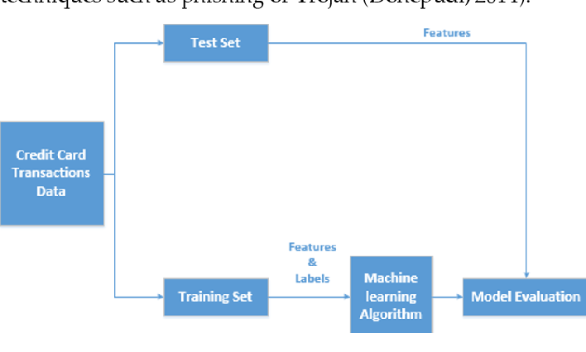

Prototype:
python 3.7.0 or 3.7.4
opencv-python==4.5.1.48
keras==2.3.1
tensorflow==1.14.0
protobuf==3.16.0
h5py==2.10.0
sklearn-extensions==0.0.2
scikit-learn==0.22.2.post1
Numpy
Pandas

Models and Diagrams:
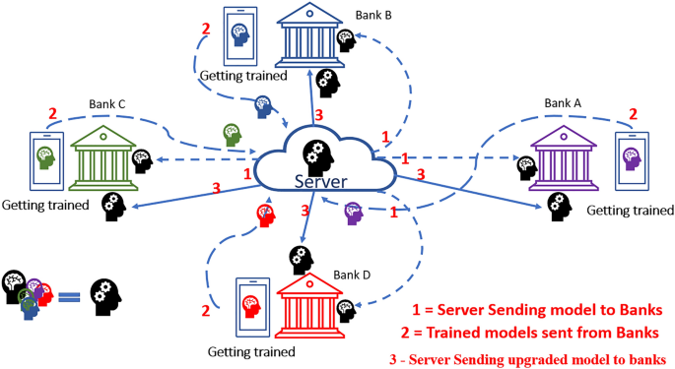
NON-FUNCTIONAL REQUIREMENT:
Usability: Usability is a quality attribute that assesses how easy user interfaces are to use. The word "usability" also refers to methods for improving ease-of-use during the design process.(how it was handle entire project easy)
Security: the quality or state of being secure: such as. a : freedom from danger : safety. b : freedom from fear or anxiety. c: freedom from the prospect of being laid off job security.
Readability: Readability is the ease with which a reader can understand a written text.
Performance: the execution of an action. : something accomplished : deed, feat. : the fulfillment of a claim, promise, or request : implementation. 3. : the action of representing a character in a play.
Availability: the quality or state of being available trying to improve the availability of affordable housing. 2 : an available person or thing.
Scalability: Scalability is the measure of a system's ability to increase or decrease in performance and cost in response to changes in application and system processing demands.

3.3. PROCESS MODEL USED WITH JUSTIFICATION
SDLC (Umbrella Model):
Umbrella Activity
Umbrella Activity
Umbrella Activity
- Feasibility Study
- TEAM FORMATION
- Project Specification PREPARATION

Business Requirement Documentation
ANALYSIS & DESIGN
CODE
UNIT TEST
DOCUMENT CONTROL

ASSESSMENT

TRAINING
INTEGRATION & SYSTEM TESTING

DELIVERY/INSTALLATION
ACCEPTANCE TEST
Requirements Gathering
SDLC is nothing but Software Development Life Cycle. It is a standard which is used by software industry to develop good software.
Stages in SDLC:
- Requirement Gathering
- Analysis
- Designing
- Coding
- Testing
- Maintenance

Requirements Gathering stage:
The requirements gathering process takes as its input the goals identified in the high-level requirements section of the project plan. Each goal will be refined into a set of one or more requirements. These requirements define the major functions of the intended application, define operational data areas and reference data areas, and define the initial data entities. Major functions include critical processes to be managed, as well as mission critical inputs, outputs and reports. A user class hierarchy is developed and associated with these major functions, data areas, and data entities. Each of these definitions is termed a Requirement. Requirements are identified by unique requirement identifiers and, at minimum, contain a requirement title and textual description.
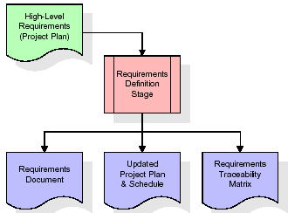
These requirements are fully described in the primary deliverables for this stage: the Requirements Document and the Requirements Traceability Matrix (RTM). The requirements document contains complete descriptions of each requirement, including diagrams and references to external documents as necessary. Note that detailed listings of database tables and fields are not included in the requirements document.
The title of each requirement is also placed into the first version of the RTM, along with the title of each goal from the project plan. The purpose of the RTM is to show that the product components developed during each stage of the software development lifecycle are formally connected to the components developed in prior stages.
In the requirements stage, the RTM consists of a list of high-level requirements, or goals, by title, with a listing of associated requirements for each goal, listed by requirement title. In this hierarchical listing, the RTM shows that each requirement developed during this stage is formally linked to a specific product goal. In this format, each requirement can be traced to a specific product goal, hence the term requirements traceability.
The outputs of the requirements definition stage include the requirements document, the RTM, and an updated project plan.
- Feasibility study is all about identification of problems in a project.
- No. of staff required to handle a project is represented as Team Formation, in this case only modules are individual tasks will be assigned to employees who are working for that project.
- Project Specifications are all about representing of various possible inputs submitting to the server and corresponding outputs along with reports maintained by administrator.
Analysis Stage:
The planning stage establishes a bird's eye view of the intended software product, and uses this to establish the basic project structure, evaluate feasibility and risks associated with the project, and describe appropriate management and technical approaches.
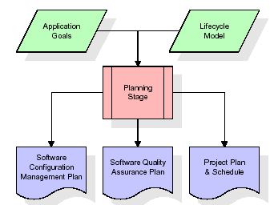
The most critical section of the project plan is a listing of high-level product requirements, also referred to as goals. All of the software product requirements to be developed during the requirements definition stage flow from one or more of these goals. The minimum information for each goal consists of a title and textual description, although additional information and references to external documents may be included. The outputs of the project planning stage are the configuration management plan, the quality assurance plan, and the project plan and schedule, with a detailed listing of scheduled activities for the upcoming Requirements stage, and high level estimates of effort for the out stages.
Designing Stage:
The design stage takes as its initial input the requirements identified in the approved requirements document. For each requirement, a set of one or more design elements will be produced as a result of interviews, workshops, and/or prototype efforts. Design elements describe the desired software features in detail, and generally include functional hierarchy diagrams, screen layout diagrams, tables of business rules, business process diagrams, pseudo code, and a complete entity-relationship diagram with a full data dictionary. These design elements are intended to describe the software in sufficient detail that skilled programmers may develop the software with minimal additional input.
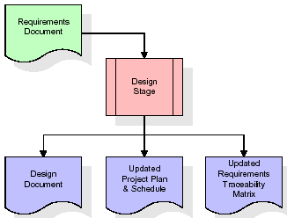
When the design document is finalized and accepted, the RTM is updated to show that each design element is formally associated with a specific requirement. The outputs of the design stage are the design document, an updated RTM, and an updated project plan.
Development (Coding) Stage:
The development stage takes as its primary input the design elements described in the approved design document. For each design element, a set of one or more software artifacts will be produced. Software artifacts include but are not limited to menus, dialogs, and data management forms, data reporting formats, and specialized procedures and functions. Appropriate test cases will be developed for each set of functionally related software artifacts, and an online help system will be developed to guide users in their interactions with the software.
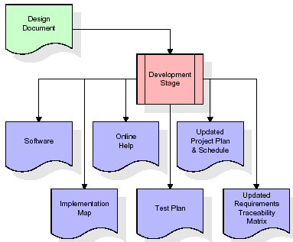

The RTM will be updated to show that each developed artifact is linked to a specific design element, and that each developed artifact has one or more corresponding test case items. At this point, the RTM is in its final configuration. The outputs of the development stage include a fully functional set of software that satisfies the requirements and design elements previously documented, an online help system that describes the operation of the software, an implementation map that identifies the primary code entry points for all major system functions, a test plan that describes the test cases to be used to validate the correctness and completeness of the software, an updated RTM, and an updated project plan.
Integration & Test Stage:
During the integration and test stage, the software artifacts, online help, and test data are migrated from the development environment to a separate test environment. At this point, all test cases are run to verify the correctness and completeness of the software. Successful execution of the test suite confirms a robust and complete migration capability. During this stage, reference data is finalized for production use and production users are identified and linked to their appropriate roles. The final reference data (or links to reference data source files) and production user list are compiled into the Production Initiation Plan.
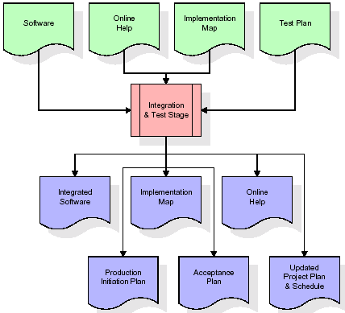
The outputs of the integration and test stage include an integrated set of software, an online help system, an implementation map, a production initiation plan that describes reference data and production users, an acceptance plan which contains the final suite of test cases, and an updated project plan.
- Installation & Acceptance Test:
During the installation and acceptance stage, the software artifacts, online help, and initial production data are loa ded onto the production server. At this point, all test cases are run to verify the correctness and completeness of the software. Successful execution of the test suite is a prerequisite to acceptance of the software by the customer.
After customer personnel have verified that the initial production data load is correct and the test suite has been executed with satisfactory results, the customer formally accepts the delivery of the software.
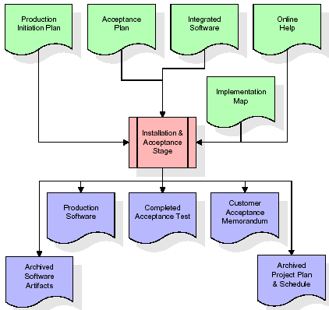
The primary outputs of the installation and acceptance stage include a production application, a completed acceptance test suite, and a memorandum of customer acceptance of the software. Finally, the PDR enters the last of the actual labor data into the project schedule and locks the project as a permanent project record. At this point the PDR "locks" the project by archiving all software items, the implementation map, the source code, and the documentation for future reference.
Maintenance:
Outer rectangle represents maintenance of a project, Maintenance team will start with requirement study, understanding of documentation later employees will be assigned work and they will undergo training on that particular assigned category. For this life cycle there is no end, it will be continued so on like an umbrella (no ending point to umbrella sticks).
3.4. Software Requirement Specification
3.4.1. Overall Description
A Software Requirements Specification (SRS) – a requirements specification for a software system is a complete description of the behavior of a system to be developed. It includes a set of use cases that describe all the interactions the users will have with the software. In addition to use cases, the SRS also contains non-functional requirements. Nonfunctional requirements are requirements which impose constraints on the design or implementation (such as performance engineering requirements, quality standards, or design constraints).
System requirements specification: A structured collection of information that embodies the requirements of a system. A business analyst, sometimes titled system analyst, is responsible for analyzing the business needs of their clients and stakeholders to help identify business problems and propose solutions. Within the systems development lifecycle domain, the BA typically performs a liaison function between the business side of an enterprise and the information technology department or external service providers. Projects are subject to three sorts of requirements:
- Business requirements describe in business terms what must be delivered or accomplished to provide value.
- Product requirements describe properties of a system or product (which could be one of several ways to accomplish a set of business requirements.)
- Process requirements describe activities performed by the developing organization. For instance, process requirements could specify. Preliminary investigation examine project feasibility, the likelihood the system will be useful to the organization. The main objective of the feasibility study is to test the Technical, Operational and Economical feasibility for adding new modules and debugging old running system. All system is feasible if they are unlimited resources and infinite time. There are aspects in the feasibility study portion of the preliminary investigation:
- ECONOMIC FEASIBILITY
A system can be developed technically and that will be used if installed must still be a good investment for the organization. In the economic feasibility, the development cost in creating the system is evaluated against the ultimate benefit derived from the new systems. Financial benefits must equal or exceed the costs. The system is economically feasible. It does not require any addition hardware or software. Since the interface for this system is developed using the existing resources and technologies available at NIC, there is nominal expenditure and economic feasibility for certain.
- Operational Feasibility
Proposed projects are beneficial only if they can be turned out into information system. That will meet the organization’s operating requirements. Operational feasibility aspects of the project are to be taken as an important part of the project implementation. This system is targeted to be in accordance with the above-mentioned issues. Beforehand, the management issues and user requirements have been taken into consideration. So, there is no question of resistance from the users that can undermine the possible application benefits. The well-planned design would ensure the optimal utilization of the computer resources and would help in the improvement of performance status.
- TECHNICAL FEASIBILITY
Earlier no system existed to cater to the needs of ‘Secure Infrastructure Implementation System’. The current system developed is technically feasible. It is a web-based user interface for audit workflow at NIC-CSD. Thus, it provides an easy access to. the users. The database’s purpose is to create, establish and maintain a workflow among various entities in order to facilitate all concerned users in their various capacities or roles. Permission to the users would be granted based on the roles specified. Therefore, it provides the technical guarantee of accuracy, reliability and security.
3.4.2. External Interface Requirements
User Interface
The user interface of this system is a user-friendly python Graphical User Interface.
Hardware Interfaces
The interaction between the user and the console is achieved through python capabilities.
Software Interfaces
The required software is python.
SYSTEM REQUIREMENT:
HARDWARE REQUIREMENTS:

Processor - Intel i3(min)
- Speed - 1.1 Ghz
- RAM - 4GB (min)
- Hard Disk - 500 GB
- Key Board - Standard Windows Keyboard
- Mouse - Two or Three Button Mouse
- Monitor - SVGA
SOFTWARE REQUIREMENTS:
- Operating System - Windows10(min)
- Programming Language - Python

4. SYSTEM DESIGN
CLASS DIAGRAM:
The class diagram is the main building block of object-oriented modeling. It is used both for general conceptual modeling of the systematic of the application, and for detailed modeling translating the models into programming code. Class diagrams can also be used for data modeling. The classes in a class diagram represent both the main objects, interactions in the application and the classes to be programmed. In the diagram, classes are represented with boxes which contain three parts:
- The upper part holds the name of the class
- The middle part contains the attributes of the class
- The bottom part gives the methods or operations the class can take or undertake
USECASE DIAGRAM:
A use case diagram at its simplest is a representation of a user's interaction with the system and depicting the specifications of a use case. A use case diagram can portray the different types of users of a system and the various ways that they interact with the system. This type of diagram is typically used in conjunction with the textual use case and will often be accompanied by other types of diagrams as well.
SEQUENCE DIAGRAM:
A sequence diagram is a kind of interaction diagram that shows how processes operate with one another and in what order. It is a construct of a Message Sequence Chart. A sequence diagram shows object interactions arranged in time sequence. It depicts the objects and classes involved in the scenario and the sequence of messages exchanged between the objects needed to carry out the functionality of the scenario. Sequence diagrams are typically associated with use case realizations in the Logical View of the system under development. Sequence diagrams are sometimes called event diagrams, event scenarios, and timing diagrams.
COLLABORATION DIAGRAM:
A collaboration diagram describes interactions among objects in terms of sequenced messages. Collaboration diagrams represent a combination of information taken from class, sequence, and use case diagrams describing both the static structure and dynamic behaviour of a system.

COMPONENT DIAGRAM:
In the Unified Modelling Language, a component diagram depicts how components are wired together to form larger components and or software systems. They are used to illustrate the structure of arbitrarily complex systems.
Components are wired together by using an assembly connector to connect the required interface of one component with the provided interface of another component. This illustrates the service consumer - service provider relationship between the two components.

DEPLOYMENT DIAGRAM:
A deployment diagram in the Unified Modeling Language models the physical deployment of artifacts on nodes. To describe a web site, for example, a deployment diagram would show what hardware components ("nodes") exist (e.g., a web server, an application server, and a database server), what software components ("artifacts") run on each node (e.g., web application, database), and how the different pieces are connected (e.g., JDBC, REST, RMI).
The nodes appear as boxes, and the artifacts allocated to each node appear as rectangles within the boxes. Nodes may have sub nodes, which appear as nested boxes. A single node in a deployment diagram may conceptually represent multiple physical nodes, such as a cluster of database servers.

ACTIVITY DIAGRAM:
Activity diagram is another important diagram in UML to describe dynamic aspects of the system. It is basically a flow chart to represent the flow form one activity to another activity. The activity can be described as an operation of the system. So, the control flow is drawn from one operation to another. This flow can be sequential, branched or concurrent.

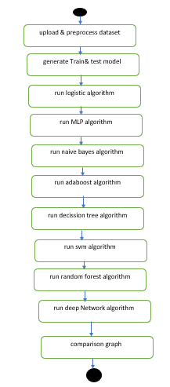
Data flow:
Data flow diagrams illustrate how data is processed by a system in terms of inputs and outputs. Data flow diagrams can be used to provide a clear representation of any business function. The technique starts with an overall picture of the business and continues by analyzing each of the functional areas of interest. This analysis can be carried out in precisely the level of detail required. The technique exploits a method called top-down expansion to conduct the analysis in a targeted way.
As the name suggests, Data Flow Diagram (DFD) is an illustration that explicates the passage of information in a process. A DFD can be easily drawn using simple symbols. Additionally, complicated processes can be easily automated by creating DFDs using easy-to-use, free downloadable diagramming tools. A DFD is a model for constructing and analyzing information processes. DFD illustrates the flow of information in a process depending upon the inputs and outputs. A DFD can also be referred to as a Process Model. A DFD demonstrates business or technical process with the support of the outside data saved, plus the data flowing from the process to another and the end results.
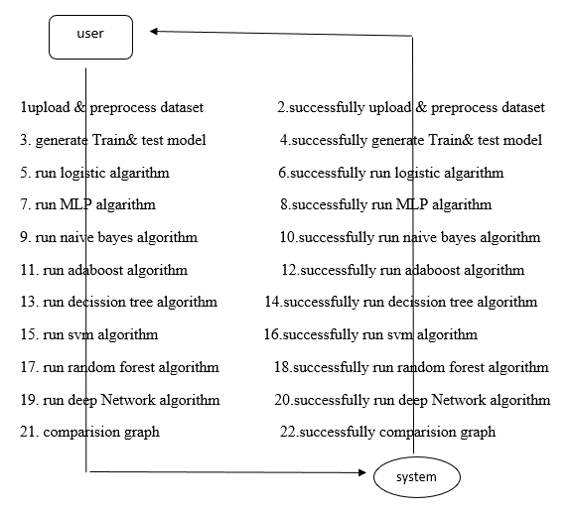
5. IMPLEMETATION
5.1 Python
Python is a general-purpose language. It has wide range of applications from Web development (like: Django and Bottle), scientific and mathematical computing (Orange, SymPy, NumPy) to desktop graphical user Interfaces (Pygame, Panda3D). The syntax of the language is clean and length of the code is relatively short. It's fun to work in Python because it allows you to think about the problem rather than focusing on the syntax.
History of Python:
Python is a fairly old language created by Guido Van Rossum. The design began in the late 1980s and was first released in February 1991.
Why Python was created?
In late 1980s, Guido Van Rossum was working on the Amoeba distributed operating system group. He wanted to use an interpreted language like ABC (ABC has simple easy-to-understand syntax) that could access the Amoeba system calls. So, he decided to create a language that was extensible. This led to design of a new language which was later named Python.
Why the name Python?
No. It wasn't named after a dangerous snake. Rossum was fan of a comedy series from late seventies. The name "Python" was adopted from the same series "Monty Python's Flying Circus".
Features of Python:
A simple language which is easier to learn
Python has a very simple and elegant syntax. It's much easier to read and write Python programs compared to other languages like: C++, Java, C#. Python makes programming fun and allows you to focus on the solution rather than syntax.
If you are a newbie, it's a great choice to start your journey with Python.
Free and open-source
You can freely use and distribute Python, even for commercial use. Not only can you use and distribute software’s written in it, you can even make changes to the Python's source code.
Python has a large community constantly improving it in each iteration.
Portability
You can move Python programs from one platform to another, and run it without any changes.
It runs seamlessly on almost all platforms including Windows, Mac OS X and Linux.
Extensible and Embeddable
Suppose an application requires high performance. You can easily combine pieces of C/C++ or other languages with Python code.
This will give your application high performance as well as scripting capabilities which other languages may not provide out of the box.
A high-level, interpreted language
Unlike C/C++, you don't have to worry about daunting tasks like memory management, garbage collection and so on.
Likewise, when you run Python code, it automatically converts your code to the language your computer understands. You don't need to worry about any lower-level operations.
Large standard libraries to solve common tasks
Python has a number of standard libraries which makes life of a programmer much easier since you don't have to write all the code yourself. For example: Need to connect MySQL database on a Web server? You can use MySQL dB library using import MySQL dB.
Standard libraries in Python are well tested and used by hundreds of people. So, you can be sure that it won't break your application.
Object-oriented
Everything in Python is an object. Object oriented programming (OOP) helps you solve a complex problem intuitively.
With OOP, you are able to divide these complex problems into smaller sets by creating objects.
Applications of Python:
1. Simple Elegant Syntax
Programming in Python is fun. It's easier to understand and write Python code. Why? The syntax feels natural. Take this source code for an example:
a = 2
b = 3
sum = a + b
print(sum)
2. Not overly strict
You don't need to define the type of a variable in Python. Also, it's not necessary to add semicolon at the end of the statement.
Python enforces you to follow good practices (like proper indentation). These small things can make learning much easier for beginners.
3. Expressiveness of the language
Python allows you to write programs having greater functionality with fewer lines of code. Here's a link to the source code of Tic-tac-toe game with a graphical interface and a smart computer opponent in less than 500 lines of code. This is just an example. You will be amazed how much you can do with Python once you learn the basics.
4. Great Community and Support
Python has a large supporting community. There are numerous active forums online which can be handy if you are stuck.
ALGORITHM:
Decision Tree:
Decision Tree is one of the most powerful and popular algorithms. Python Decision-tree algorithm falls under the category of supervised learning algorithms. It works for both continuous as well as categorical output variables. In this article, We are going to implement a Decision tree in Python algorithm on the Balance Scale Weight & Distance Database presented on the UCI. A Decision tree is a tree-like structure that represents a set of decisions and their possible consequences. Each node in the tree represents a decision, and each branch represents an outcome of that decision. The leaves of the tree represent the final decisions or predictions.
Decision trees are created by recursively partitioning the data into smaller and smaller subsets. At each partition, the data is split based on a specific feature, and the split is made in a way that maximizes the information gain.
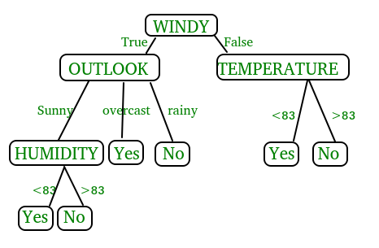
In the above figure, decision tree is a flowchart-like tree structure that is used to make decisions. It consists of Root Node(WINDY), Internal nodes(OUTLOOK, TEMPERATURE), which represent tests on attributes, and leaf nodes, which represent the final decisions. The branches of the tree represent the possible outcomes of the tests.

Key Components of Decision Trees in Python
- Root Node: The decision tree’s starting node, which stands for the complete dataset.
- Branch Nodes: Internal nodes that represent decision points, where the data is split based on a specific attribute.
- Leaf Nodes: Final categorization or prediction-representing terminal nodes.
- Decision Rules: Rules that govern the splitting of data at each branch node.
- Attribute Selection: The process of choosing the most informative attribute for each split.
- Splitting Criteria: Metrics like information gain, entropy, or the Gini Index are used to calculate the optimal split.

Assumptions we make while using Decision tree
- At the beginning, we consider the whole training set as the root.
- Attributes are assumed to be categorical for information gain and for gini index, attributes are assumed to be continuous.
- On the basis of attribute values records are distributed recursively.
- We use statistical methods for ordering attributes as root or internal node
Implementing Decision Tree Using Python:
from sklearn.datasets import load_iris
from sklearn.model_selection import train_test_split
from sklearn.tree import DecisionTreeClassifier
from sklearn.metrics import accuracy_score
# Load the Iris dataset
iris = load_iris()
X = iris.data
y = iris.target
# Split the dataset into training and testing sets
X_train, X_test, y_train, y_test = train_test_split(X, y, test_size=0.2, random_state=42)
# Initialize the decision tree classifier
clf = DecisionTreeClassifier()
# Train the classifier on the training data
clf.fit(X_train, y_train)
# Make predictions on the testing data
y_pred = clf.predict(X_test)
# Calculate the accuracy of the classifier
accuracy = accuracy_score(y_test, y_pred)
print("Accuracy:", accuracy)
In This Example :
- We first import necessary modules from scikit-learn.
- We load the Iris dataset, a popular dataset for classification tasks.
- We split the dataset into training and testing sets using the train test split function.
- We initialize a Decision Tree Classifier.
- We train the classifier on the training data using the fit method.
- We make predictions on the testing data using the predict method.
- Finally, we calculate the accuracy of the classifier using the accuracy score function.

3.Random Forest:
Machine learning, a fascinating blend of computer science and statistics, has witnessed incredible progress, with one standout algorithm being the Random Forest. Random forests or Random Decision Trees is a collaborative team of decision trees that work together to provide a single output. Originating in 2001 through Leo Breiman, Random Forest has become a cornerstone for machine learning enthusiasts. In this article, we will explore the fundamentals and implementation of Random Forest Algorithm.
Random Forest algorithm is a powerful tree learning technique in Machine Learning. It works by creating a number of Decision Trees during the training phase. Each tree is constructed using a random subset of the data set to measure a random subset of features in each partition. This randomness introduces variability among individual trees, reducing the risk of overfitting and improving overall prediction performance. In prediction, the algorithm aggregates the results of all trees, either by voting (for classification tasks) or by averaging (for regression tasks) This collaborative decision-making process, supported by multiple trees with their insights, provides an example stable and precise results. Random forests are widely used for classification and regression functions, which are known for their ability to handle complex data, reduce overfitting, and provide reliable forecasts in different environments.
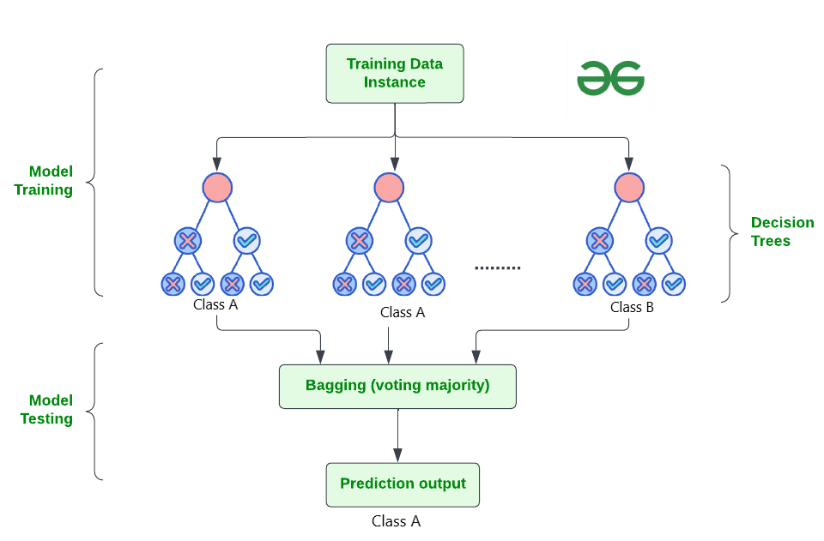

How Does Random Forest Work?
The random Forest algorithm works in several steps which are discussed below–>
- Ensemble of Decision Trees: Random Forest leverages the power of ensemble learning by constructing an army of Decision Trees. These trees are like individual experts, each specializing in a particular aspect of the data. Importantly, they operate independently, minimizing the risk of the model being overly influenced by the nuances of a single tree.
- Random Feature Selection: To ensure that each decision tree in the ensemble brings a unique perspective, Random Forest employs random feature selection. During the training of each tree, a random subset of features is chosen. This randomness ensures that each tree focuses on different aspects of the data, fostering a diverse set of predictors within the ensemble.
- Bootstrap Aggregating or Bagging: The technique of bagging is a cornerstone of Random Forest’s training strategy which involves creating multiple bootstrap samples from the original dataset, allowing instances to be sampled with replacement. This results in different subsets of data for each decision tree, introducing variability in the training process and making the model more robust.
- Decision Making and Voting: When it comes to making predictions, each decision tree in the Random Forest casts its vote. For classification tasks, the final prediction is determined by the mode (most frequent prediction) across all the trees. In regression tasks, the average of the individual tree predictions is taken. This internal voting mechanism ensures a balanced and collective decision-making process.

Key Features of Random Forest
Some of the Key Features of Random Forest are discussed below–>
- High Predictive Accuracy: Imagine Random Forest as a team of decision-making wizards. Each wizard (decision tree) looks at a part of the problem, and together, they weave their insights into a powerful prediction tapestry. This teamwork often results in a more accurate model than what a single wizard could achieve.
- Resistance to Overfitting: Random Forest is like a cool-headed mentor guiding its apprentices (decision trees). Instead of letting each apprentice memorize every detail of their training, it encourages a more well-rounded understanding. This approach helps prevent getting too caught up with the training data which makes the model less prone to overfitting.
- Large Datasets Handling: Dealing with a mountain of data? Random Forest tackles it like a seasoned explorer with a team of helpers (decision trees). Each helper takes on a part of the dataset, ensuring that the expedition is not only thorough but also surprisingly quick.
- Variable Importance Assessment: Think of Random Forest as a detective at a crime scene, figuring out which clues (features) matter the most. It assesses the importance of each clue in solving the case, helping you focus on the key elements that drive predictions.
- Built-in Cross-Validation: Random Forest is like having a personal coach that keeps you in check. As it trains each decision tree, it also sets aside a secret group of cases (out-of-bag) for testing. This built-in validation ensures your model doesn’t just ace the training but also performs well on new challenges.
- Handling Missing Values: Life is full of uncertainties, just like datasets with missing values. Random Forest is the friend who adapts to the situation, making predictions using the information available. It doesn’t get flustered by missing pieces; instead, it focuses on what it can confidently tell us.
- Parallelization for Speed: Random Forest is your time-saving buddy. Picture each decision tree as a worker tackling a piece of a puzzle simultaneously. This parallel approach taps into the power of modern tech, making the whole process faster and more efficient for handling large-scale projects.

Implement Random Forest for Classification :
# Import necessary libraries
import pandas as pd
from sklearn.model_selection import train_test_split
from sklearn.ensemble import RandomForestClassifier
from sklearn.metrics import accuracy_score, classification_report
import warnings
warnings.filterwarnings('ignore')
# Load the Titanic dataset
url = "https://raw.githubusercontent.com/datasciencedojo/datasets/master/titanic.csv"
titanic_data = pd.read_csv(url)
# Drop rows with missing target values
titanic_data = titanic_data.dropna(subset=['Survived'])
# Select relevant features and target variable
X = titanic_data[['Pclass', 'Sex', 'Age', 'SibSp', 'Parch', 'Fare']]
y = titanic_data['Survived']
# Convert categorical variable 'Sex' to numerical using .loc
X.loc[:, 'Sex'] = X['Sex'].map({'female': 0, 'male': 1})
# Handle missing values in the 'Age' column using .loc
X.loc[:, 'Age'].fillna(X['Age'].median(), inplace=True)

# Split the dataset into training and testing sets
X_train, X_test, y_train, y_test = train_test_split(X, y, test_size=0.2, random_state=42)
# Create a Random Forest Classifier
rf_classifier = RandomForestClassifier(n_estimators=100, random_state=42)
# Train the classifier
rf_classifier.fit(X_train, y_train)
# Make predictions on the test set
y_pred = rf_classifier.predict(X_test)
# Evaluate the model
accuracy = accuracy_score(y_test, y_pred)
classification_rep = classification_report(y_test, y_pred)
# Print the results
print(f"Accuracy: {accuracy:.2f}")
print("\nClassification Report:\n", classification_rep)
Output:
Accuracy: 0.80

Classification Report:
precision recall f1-score support

0 0.82 0.85 0.83 105
1 0.77 0.73 0.75 74

accuracy 0.80 179
macro avg 0.79 0.79 0.79 179
weighted avg 0.80 0.80 0.80 179

In the above code, we’re using a Random Forest Classifier to make sense of the Titanic dataset. First, we gather our tools – importing libraries to handle data and evaluate our model. Next, we dive into the Titanic dataset, fixing missing information and choosing important details like a detective solving a mystery. We even teach the computer to understand ‘male’ and ‘female’ by turning them into numbers. Then, we split our dataset into pieces – one part to train our model, and the other to test its newfound skills. Our Random Forest Classifier is like a student, learning from the training set. Once trained, it faces a test – making predictions on the test set. We’re like judges, using a classification report to grade how well our model did.
4. Support Vector Machine (SVM):
Support Vector Machine (SVM) is a powerful machine learning algorithm used for linear or nonlinear classification, regression, and even outlier detection tasks. SVMs can be used for a variety of tasks, such as text classification, image classification, spam detection, handwriting identification, gene expression analysis, face detection, and anomaly detection. SVMs are adaptable and efficient in a variety of applications because they can manage high-dimensional data and nonlinear relationships. SVM algorithms are very effective as we try to find the maximum separating hyperplane between the different classes available in the target feature. Support Vector Machine (SVM) is a supervised machine learning algorithm used for both classification and regression. Though we say regression problems as well it’s best suited for classification. The main objective of the SVM algorithm is to find the optimal hyperplane in an N-dimensional space that can separate the data points in different classes in the feature space. The hyperplane tries that the margin between the closest points of different classes should be as maximum as possible. The dimension of the hyperplane depends upon the number of features. If the number of input features is two, then the hyperplane is just a line. If the number of input features is three, then the hyperplane becomes a 2-D plane. It becomes difficult to imagine when the number of features exceeds three.
Let’s consider two independent variables x₁, x_{2,} and one dependent variable which is either a blue circle or a red circle.
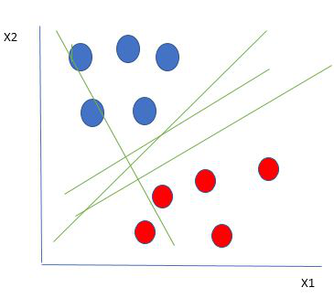
Linearly Separable Data points
From the figure above it’s very clear that there are multiple lines (our hyperplane here is a line because we are considering only two input features x₁, x₂) that segregate our data points or do a classification between red and blue circles. So how do we choose the best line or in general the best hyperplane that segregates our data points?

One reasonable choice as the best hyperplane is the one that represents the largest separation or margin between the two classes.
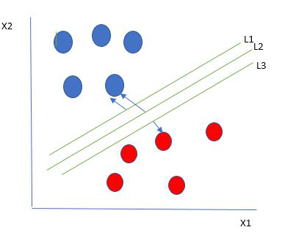
Multiple hyperplanes separate the data from two classes
So we choose the hyperplane whose distance from it to the nearest data point on each side is maximized. If such a hyperplane exists it is known as the maximum-margin hyperplane/hard margin. So from the above figure, we choose L2. Let’s consider a scenario like shown below
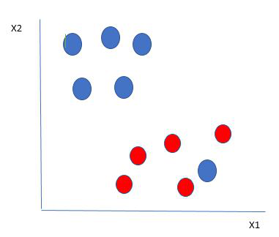
Selecting hyperplane for data with outlier
Here we have one blue ball in the boundary of the red ball. So how does SVM classify the data? It’s simple! The blue ball in the boundary of red ones is an outlier of blue balls. The SVM algorithm has the characteristics to ignore the outlier and finds the best hyperplane that maximizes the margin. SVM is robust to outliers.
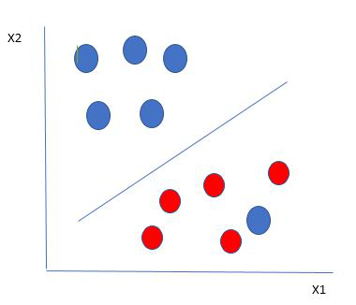
Hyperplane which is the most optimized one
So in this type of data point what SVM does is, finds the maximum margin as done with previous data sets along with that it adds a penalty each time a point crosses the margin. So the margins in these types of cases are called soft margins. When there is a soft margin to the data set, the SVM tries to minimize (1/margin+∧(∑penalty)). Hinge loss is a commonly used penalty. If no violations no hinge loss.If violations hinge loss proportional to the distance of violation.
Till now, we were talking about linearly separable data(the group of blue balls and red balls are separable by a straight line/linear line). What to do if data are not linearly separable?
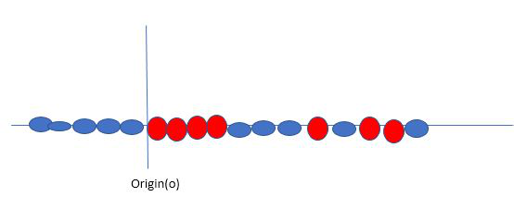
Original 1D dataset for classification
Say, our data is shown in the figure above. SVM solves this by creating a new variable using a kernel. We call a point x_{i} on the line and we create a new variable y_{i} as a function of distance from origin o.so if we plot this we get something like as shown below
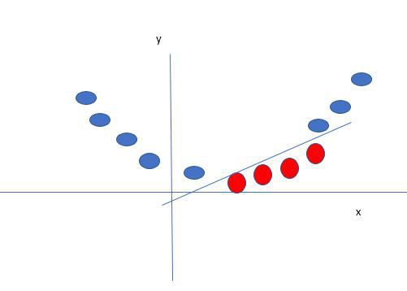
Mapping 1D data to 2D to become able to separate the two classes
In this case, the new variable y is created as a function of distance from the origin. A non-linear function that creates a new variable is referred to as a kernel.

Support Vector Machine Terminology
- Hyperplane: Hyperplane is the decision boundary that is used to separate the data points of different classes in a feature space. In the case of linear classifications, it will be a linear equation i.e. wx+b = 0.
- Support Vectors: Support vectors are the closest data points to the hyperplane, which makes a critical role in deciding the hyperplane and margin.
- Margin: Margin is the distance between the support vector and hyperplane. The main objective of the support vector machine algorithm is to maximize the margin. The wider margin indicates better classification performance.
- Kernel: Kernel is the mathematical function, which is used in SVM to map the original input data points into high-dimensional feature spaces, so, that the hyperplane can be easily found out even if the data points are not linearly separable in the original input space. Some of the common kernel functions are linear, polynomial, radial basis function(RBF), and sigmoid.
- Hard Margin: The maximum-margin hyperplane or the hard margin hyperplane is a hyperplane that properly separates the data points of different categories without any misclassifications.
- Soft Margin: When the data is not perfectly separable or contains outliers, SVM permits a soft margin technique. Each data point has a slack variable introduced by the soft-margin SVM formulation, which softens the strict margin requirement and permits certain misclassifications or violations. It discovers a compromise between increasing the margin and reducing violations.
- C: Margin maximisation and misclassification fines are balanced by the regularisation parameter C in SVM. The penalty for going over the margin or misclassifying data items is decided by it. A stricter penalty is imposed with a greater value of C, which results in a smaller margin and perhaps fewer misclassifications.
- Hinge Loss: A typical loss function in SVMs is hinge loss. It punishes incorrect classifications or margin violations. The objective function in SVM is frequently formed by combining it with the regularisation term.
- Dual Problem: A dual Problem of the optimisation problem that requires locating the Lagrange multipliers related to the support vectors can be used to solve SVM. The dual formulation enables the use of kernel tricks and more effective computing.

SVM implementation in Python
Predict if cancer is Benign or malignant. Using historical data about patients diagnosed with cancer enables doctors to differentiate malignant cases and benign ones are given independent attributes.

Steps
- Load the breast cancer dataset from sklearn.datasets
- Separate input features and target variables.
- Buil and train the SVM classifiers using RBF kernel.
- Plot the scatter plot of the input features.
- Plot the decision boundary.
- Plot the decision boundary
Example:
# Load the important packages
from sklearn.datasets import load_breast_cancer
import matplotlib.pyplot as plt
from sklearn.inspection import DecisionBoundaryDisplay
from sklearn.svm import SVC
# Load the datasets
cancer = load_breast_cancer()
X = cancer.data[:, :2]
y = cancer.target
#Build the model
svm = SVC(kernel="rbf", gamma=0.5, C=1.0)
# Trained the model
svm.fit(X, y)
# Plot Decision Boundary
DecisionBoundaryDisplay.from_estimator(
svm,
X,
response_method="predict",
cmap=plt.cm.Spectral,
alpha=0.8,
xlabel=cancer.feature_names[0],
ylabel=cancer.feature_names[1],
)
# Scatter plot
plt.scatter(X[:, 0], X[:, 1], c=y, s=20, edgecolors="k")
plt.show()
Output:
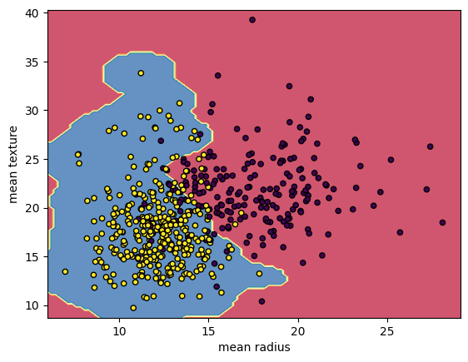
Breast Cancer Classifications with SVM RBF kernel
5.Naïve Bayes:
A Naive Bayes classifiers, a family of algorithms based on Bayes’ Theorem. Despite the “naive” assumption of feature independence, these classifiers are widely utilized for their simplicity and efficiency in machine learning. The article delves into theory, implementation, and applications, shedding light on their practical utility despite oversimplified assumptions.

What is Naive Bayes Classifiers?
Naive Bayes classifiers are a collection of classification algorithms based on Bayes’ Theorem. It is not a single algorithm but a family of algorithms where all of them share a common principle, i.e. every pair of features being classified is independent of each other. To start with, let us consider a dataset.
One of the most simple and effective classification algorithms, the Naïve Bayes classifier aids in the rapid development of machine learning models with rapid prediction capabilities.
Naïve Bayes algorithm is used for classification problems. It is highly used in text classification. In text classification tasks, data contains high dimension (as each word represent one feature in the data). It is used in spam filtering, sentiment detection, rating classification etc. The advantage of using naïve Bayes is its speed. It is fast and making prediction is easy with high dimension of data.This model predicts the probability of an instance belongs to a class with a given set of feature value. It is a probabilistic classifier. It is because it assumes that one feature in the model is independent of existence of another feature. In other words, each feature contributes to the predictions with no relation between each other. In real world, this condition satisfies rarely. It uses Bayes theorem in the algorithm for training and prediction

Why it is Called Naive Bayes?
The “Naive” part of the name indicates the simplifying assumption made by the Naïve Bayes classifier. The classifier assumes that the features used to describe an observation are conditionally independent, given the class label. The “Bayes” part of the name refers to Reverend Thomas Bayes, an 18th-century statistician and theologian who formulated Bayes’ theorem.
Consider a fictional dataset that describes the weather conditions for playing a game of golf. Given the weather conditions, each tuple classifies the conditions as fit(“Yes”) or unfit(“No”) for playing golf.Here is a tabular representation of our dataset.
The assumptions made by Naive Bayes are not generally correct in real-world situations. In-fact, the independence assumption is never correct but often works well in practice.Now, before moving to the formula for Naive Bayes, it is important to know about Bayes’ theorem.

Bayes’ Theorem
Bayes’ Theorem finds the probability of an event occurring given the probability of another event that has already occurred. Bayes’ theorem is stated mathematically as the following equation:
P(A∣B)=P(B)P(B∣A)P(A)​
where A and B are events and P(B) ≠ 0
- Basically, we are trying to find probability of event A, given the event B is true. Event B is also termed as evidence.
- P(A) is the priori of A (the prior probability, i.e. Probability of event before evidence is seen). The evidence is an attribute value of an unknown instance(here, it is event B).
- P(B) is Marginal Probability: Probability of Evidence.
- P(A|B) is a posteriori probability of B, i.e. probability of event after evidence is seen.
- P(B|A) is Likelihood probability i.e the likelihood that a hypothesis will come true based on the evidence.

Naive Bayes implementation in Python
# load the iris dataset
from sklearn.datasets import load_iris
iris = load_iris()
# store the feature matrix (X) and response vector (y)
X = iris.data
y = iris.target
# splitting X and y into training and testing sets
from sklearn.model_selection import train_test_split
X_train, X_test, y_train, y_test = train_test_split(X, y, test_size=0.4, random_state=1)
# training the model on training set
from sklearn.naive_bayes import GaussianNB
gnb = GaussianNB()
gnb.fit(X_train, y_train)
# making predictions on the testing set
y_pred = gnb.predict(X_test)
# comparing actual response values (y_test) with predicted response values (y_pred)
from sklearn import metrics
print("Gaussian Naive Bayes model accuracy(in %):", metrics.accuracy_score(y_test, y_pred)*100)
OUTPUT: Gaussian Naive Bayes model accuracy(in %): 95.0

5.2 Sample Code:
from tkinter import messagebox
from tkinter import *
from tkinter import simpledialog
import tkinter
from tkinter import filedialog
from tkinter.filedialog import askopenfilename
import numpy as np
import matplotlib.pyplot as plt
import pandas as pd
from sklearn.preprocessing import normalize
from sklearn.metrics import accuracy_score
from sklearn.model_selection import train_test_split
import os
from sklearn.metrics import confusion_matrix
from sklearn.metrics import accuracy_score
from sklearn.tree import DecisionTreeClassifier
from sklearn.naive_bayes import GaussianNB
from sklearn import svm
from sklearn.metrics import precision_score
from sklearn.metrics import recall_score
from sklearn.metrics import f1_score
import seaborn as sns
import webbrowser
from sklearn.ensemble import RandomForestClassifier
from sklearn.linear_model import LogisticRegression
from sklearn.neural_network import MLPClassifier
from sklearn.ensemble import AdaBoostClassifier
from keras.utils.np_utils import to_categorical
from keras.layers import MaxPooling2D
from keras.layers import Dense, Dropout, Activation, Flatten
from keras.layers import Convolution2D
from keras.models import Sequential
from keras.models import model_from_json
import pickle

global filename

global X,Y
global dataset
global main
global text
accuracy = []
precision = []
recall = []
fscore = []
global X_train, X_test, y_train, y_test, predict_cls
global classifier

main = tkinter.Tk()
main.title("Comparative Study of Machine Learning Algorithms for Fraud Detection in Blockchain") #designing main screen
main.geometry("1300x1200")

#fucntion to upload dataset
def uploadDataset():
global filename
global dataset
text.delete('1.0', END)
filename = filedialog.askopenfilename(initialdir="Dataset")
text.insert(END,filename+" loaded\n\n")
dataset = pd.read_csv(filename)
text.insert(END,"Dataset before preprocessing\n\n")
text.insert(END,str(dataset.head()))
text.update_idletasks()
label = dataset.groupby('FLAG').size()
label.plot(kind="bar")
plt.title("Blockchain Fraud Detection Graph 0 means Normal & 1 means Fraud")
plt.show()

#function to perform dataset preprocessing
def trainTest():
global X,Y
global dataset
global X_train, X_test, y_train, y_test
text.delete('1.0', END)
#replace missing values with 0
dataset.fillna(0, inplace = True)
Y = dataset['FLAG'].ravel()
dataset = dataset.values
X = dataset[:,4:dataset.shape[1]-2]
X = normalize(X)
indices = np.arange(X.shape[0])
np.random.shuffle(indices)
X = X[indices]
Y = Y[indices]
X = X[0:5000]
Y = Y[0:5000]
print(Y)
print(X)
text.insert(END,"Dataset after features normalization\n\n")
text.insert(END,str(X)+"\n\n")
text.insert(END,"Total records found in dataset : "+str(X.shape[0])+"\n")
text.insert(END,"Total features found in dataset: "+str(X.shape[1])+"\n\n")
X_train, X_test, y_train, y_test = train_test_split(X, Y, test_size=0.2)
text.insert(END,"Dataset Train and Test Split\n\n")
text.insert(END,"80% dataset records used to train ML algorithms : "+str(X_train.shape[0])+"\n")
text.insert(END,"20% dataset records used to train ML algorithms : "+str(X_test.shape[0])+"\n")

def calculateMetrics(algorithm, predict, y_test):
a = accuracy_score(y_test,predict)*100
p = precision_score(y_test, predict,average='macro') * 100
r = recall_score(y_test, predict,average='macro') * 100
f = f1_score(y_test, predict,average='macro') * 100
accuracy.append(a)
precision.append(p)
recall.append(r)
fscore.append(f)
text.insert(END,algorithm+" Accuracy : "+str(a)+"\n")
text.insert(END,algorithm+" Precision : "+str(p)+"\n")
text.insert(END,algorithm+" Recall : "+str(r)+"\n")
text.insert(END,algorithm+" FScore : "+str(f)+"\n\n")

def runLogisticRegression():
global X,Y, X_train, X_test, y_train, y_test
global accuracy, precision,recall, fscore
accuracy.clear()
precision.clear()
recall.clear()
fscore.clear()
text.delete('1.0', END)
lr = LogisticRegression()
lr.fit(X, Y)
predict = lr.predict(X_test)
calculateMetrics("Logistic Regression", predict, y_test)

def runMLP():
mlp = MLPClassifier()
mlp.fit(X_train, y_train)
predict = mlp.predict(X_test)
calculateMetrics("MLP", predict, y_test)

def runNaiveBayes():
cls = GaussianNB()
cls.fit(X_train, y_train)
predict = cls.predict(X_test)
calculateMetrics("Naive Bayes", predict, y_test)

def runAdaBoost():
cls = AdaBoostClassifier()
cls.fit(X_train, y_train)
predict = cls.predict(X_test)
calculateMetrics("AdaBoost", predict, y_test)

def runDT():
global predict_cls
cls = DecisionTreeClassifier()
cls.fit(X_train, y_train)
predict = cls.predict(X_test)
calculateMetrics("Decision Tree", predict, y_test)

def runSVM():
cls = svm.SVC()
cls.fit(X_train, y_train)
predict = cls.predict(X_test)
calculateMetrics("SVM", predict, y_test)

def runRF():
global predict_cls
rf = RandomForestClassifier()
rf.fit(X_train, y_train)
predict = rf.predict(X_test)
predict_cls = rf
calculateMetrics("Random Forest", predict, y_test)

def predict():
global predict_cls
text.delete('1.0', END)
filename = filedialog.askopenfilename(initialdir="Dataset")
dataset = pd.read_csv(filename)
dataset.fillna(0, inplace = True)
dataset = dataset.values
X = dataset[:,4:dataset.shape[1]-2]
X1 = normalize(X)
prediction = predict_cls.predict(X1)
print(prediction)
for i in range(len(prediction)):
if prediction[i] == 0:
text.insert(END,"Test DATA : "+str(X[i])+" ===> PREDICTED AS NORMAL\n\n")
else:
text.insert(END,"Test DATA : "+str(X[i])+" ===> PREDICTED AS FRAUD\n\n")

def runDeepNetwork():
global X, Y
X = np.reshape(X, (X.shape[0], X.shape[1], 1, 1))
Y = to_categorical(Y)
X_train, X_test, y_train, y_test = train_test_split(X, Y, test_size=0.2)
if os.path.exists('model/model.json'):
with open('model/model.json', "r") as json_file:
loaded_model_json = json_file.read()
classifier = model_from_json(loaded_model_json)
json_file.close()
classifier.load_weights("model/model_weights.h5")
classifier._make_predict_function()
else:
classifier = Sequential()
classifier.add(Convolution2D(32, 1, 1, input_shape = (X_train.shape[1], X_train.shape[2], X_train.shape[3]), activation = 'relu'))
classifier.add(MaxPooling2D(pool_size = (1, 1)))
classifier.add(Convolution2D(32, 1, 1, activation = 'relu'))
classifier.add(MaxPooling2D(pool_size = (1, 1)))
classifier.add(Flatten())
classifier.add(Dense(output_dim = 256, activation = 'relu'))
classifier.add(Dense(output_dim = Y.shape[1], activation = 'softmax'))
print(classifier.summary())
classifier.compile(optimizer = 'adam', loss = 'categorical_crossentropy', metrics = ['accuracy'])
hist = classifier.fit(X, Y, batch_size=16, epochs=10, shuffle=True, verbose=2)
classifier.save_weights('model/model_weights.h5')
model_json = classifier.to_json()
with open("model/model.json", "w") as json_file:
json_file.write(model_json)
json_file.close()
predict = classifier.predict(X_test)
predict = np.argmax(predict, axis=1)
y_test = np.argmax(y_test, axis=1)
calculateMetrics("Deep Neural Network", predict, y_test)

def graph():
output = "<html><body><table align=center border=1><tr><th>Algorithm Name</th><th>Accuracy</th><th>Precision</th><th>Recall</th>"
output+="<th>FSCORE</th></tr>"
output+="<tr><td>Logistic Regression Algorithm</td><td>"+str(accuracy[0])+"</td><td>"+str(precision[0])+"</td><td>"+str(recall[0])+"</td><td>"+str(fscore[0])+"</td></tr>"
output+="<tr><td>MLP Algorithm</td><td>"+str(accuracy[1])+"</td><td>"+str(precision[1])+"</td><td>"+str(recall[1])+"</td><td>"+str(fscore[1])+"</td></tr>"
output+="<tr><td>Naive Bayes Algorithm</td><td>"+str(accuracy[2])+"</td><td>"+str(precision[2])+"</td><td>"+str(recall[2])+"</td><td>"+str(fscore[2])+"</td></tr>"
output+="<tr><td>AdaBoost Algorithm</td><td>"+str(accuracy[3])+"</td><td>"+str(precision[3])+"</td><td>"+str(recall[3])+"</td><td>"+str(fscore[3])+"</td></tr>"
output+="<tr><td>Decision Tree Algorithm</td><td>"+str(accuracy[4])+"</td><td>"+str(precision[4])+"</td><td>"+str(recall[4])+"</td><td>"+str(fscore[4])+"</td></tr>"
output+="<tr><td>SVM Algorithm</td><td>"+str(accuracy[5])+"</td><td>"+str(precision[5])+"</td><td>"+str(recall[5])+"</td><td>"+str(fscore[5])+"</td></tr>"
output+="<tr><td>Random Forest Algorithm</td><td>"+str(accuracy[6])+"</td><td>"+str(precision[6])+"</td><td>"+str(recall[6])+"</td><td>"+str(fscore[6])+"</td></tr>"
output+="<tr><td>Deep Neural Network Algorithm</td><td>"+str(accuracy[7])+"</td><td>"+str(precision[7])+"</td><td>"+str(recall[7])+"</td><td>"+str(fscore[7])+"</td></tr>"
output+="</table></body></html>"
f = open("table.html", "w")
f.write(output)
f.close()
webbrowser.open("table.html",new=2)

df = pd.DataFrame([['Logistic Regression','Precision',precision[0]],['Logistic Regression','Recall',recall[0]],['Logistic Regression','F1 Score',fscore[0]],['Logistic Regression','Accuracy',accuracy[0]],
['MLP','Precision',precision[1]],['MLP','Recall',recall[1]],['MLP','F1 Score',fscore[1]],['MLP','Accuracy',accuracy[1]],
['Naive Bayes','Precision',precision[2]],['Naive Bayes','Recall',recall[2]],['Naive Bayes','F1 Score',fscore[2]],['Naive Bayes','Accuracy',accuracy[2]],
['AdaBoost','Precision',precision[3]],['AdaBoost','Recall',recall[3]],['AdaBoost','F1 Score',fscore[3]],['AdaBoost','Accuracy',accuracy[3]],
['Decision Tree','Precision',precision[4]],['Decision Tree','Recall',recall[4]],['Decision Tree','F1 Score',fscore[4]],['Decision Tree','Accuracy',accuracy[4]],
['SVM','Precision',precision[5]],['SVM','Recall',recall[5]],['SVM','F1 Score',fscore[5]],['SVM','Accuracy',accuracy[5]],
['Random Forest','Precision',precision[6]],['Random Forest','Recall',recall[6]],['Random Forest','F1 Score',fscore[6]],['Random Forest','Accuracy',accuracy[6]],
['Deep Neural Network','Precision',precision[7]],['Deep Neural Network','Recall',recall[7]],['Deep Neural Network','F1 Score',fscore[7]],['Deep Neural Network','Accuracy',accuracy[7]],
],columns=['Parameters','Algorithms','Value'])
df.pivot("Parameters", "Algorithms", "Value").plot(kind='bar')
plt.show()

font = ('times', 16, 'bold')
title = Label(main, text='Comparative Study of Machine Learning Algorithms for Fraud Detection in Blockchain')
title.config(bg='greenyellow', fg='dodger blue')
title.config(font=font)
title.config(height=3, width=120)
title.place(x=0,y=5)

font1 = ('times', 12, 'bold')
text=Text(main,height=20,width=150)
scroll=Scrollbar(text)
text.configure(yscrollcommand=scroll.set)
text.place(x=50,y=120)
text.config(font=font1)

font1 = ('times', 13, 'bold')
uploadButton = Button(main, text="Upload & Preprocess Dataset", command=uploadDataset)
uploadButton.place(x=50,y=550)
uploadButton.config(font=font1)

traintestButton = Button(main, text="Generate Train & Test Model", command=trainTest)
traintestButton.place(x=330,y=550)
traintestButton.config(font=font1)

lrButton = Button(main, text="Run Logistic Regression Algorithm", command=runLogisticRegression)
lrButton.place(x=630,y=550)
lrButton.config(font=font1)

mlpButton = Button(main, text="Run MLP Algorithm", command=runMLP)
mlpButton.place(x=950,y=550)
mlpButton.config(font=font1)

nbButton = Button(main, text="Run Naive Bayes Algorithm", command=runNaiveBayes)
nbButton.place(x=50,y=600)
nbButton.config(font=font1)

adaboostButton = Button(main, text="Run AdaBoost Algorithm", command=runAdaBoost)
adaboostButton.place(x=330,y=600)
adaboostButton.config(font=font1)

dtButton = Button(main, text="Run Decision Tree Algorithm", command=runDT)
dtButton.place(x=630,y=600)
dtButton.config(font=font1)

svmButton = Button(main, text="Run SVM Algorithm", command=runSVM)
svmButton.place(x=950,y=600)
svmButton.config(font=font1)

rfButton = Button(main, text="Run Random Forest Algorithm", command=runRF)
rfButton.place(x=50,y=650)
rfButton.config(font=font1)

dnButton = Button(main, text="Run Deep Network Algorithm", command=runDeepNetwork)
dnButton.place(x=330,y=650)
dnButton.config(font=font1)

graphButton = Button(main, text="Comparison Graph", command=graph)
graphButton.place(x=630,y=650)
graphButton.config(font=font1)

predictButton = Button(main, text="Predict Fraud ", command=predict)
predictButton.place(x=950,y=650)
predictButton.config(font=font1)

main.config(bg='LightSkyBlue')
main.mainloop()
6. TESTING:
Implementation and Testing:
Implementation is one of the most important tasks in project is the phase in which one has to be cautions because all the efforts undertaken during the project will be very interactive. Implementation is the most crucial stage in achieving successful system and giving the users confidence that the new system is workable and effective. Each program is tested individually at the time of development using the sample data and has verified that these programs link together in the way specified in the program specification. The computer system and its environment are tested to the satisfaction of the user.
Implementation
The implementation phase is less creative than system design. It is primarily concerned with user training, and file conversion. The system may be requiring extensive user training. The initial parameters of the system should be modifies as a result of a programming. A simple operating procedure is provided so that the user can understand the different functions clearly and quickly. The different reports can be obtained either on the inkjet or dot matrix printer, which is available at the disposal of the user. The proposed system is very easy to implement. In general implementation is used to mean the process of converting a new or revised system design into an operational one.

Testing
Testing is the process where the test data is prepared and is used for testing the modules individually and later the validation given for the fields. Then the system testing takes place which makes sure that all components of the system property functions as a unit. The test data should be chosen such that it passed through all possible condition. Actually testing is the state of implementation which aimed at ensuring that the system works accurately and efficiently before the actual operation commence. The following is the description of the testing strategies, which were carried out during the testing period.

System Testing
Testing has become an integral part of any system or project especially in the field of information technology. The importance of testing is a method of justifying, if one is ready to move further, be it to be check if one is capable to with stand the rigors of a particular situation cannot be underplayed and that is why testing before development is so critical. When the software is developed before it is given to user to use the software must be tested whether it is solving the purpose for which it is developed. This testing involves various types through which one can ensure the software is reliable. The program was tested logically and pattern of execution of the program for a set of data are repeated. Thus the code was exhaustively checked for all possible correct data and the outcomes were also checked.
Module Testing
To locate errors, each module is tested individually. This enables us to detect error and correct it without affecting any other modules. Whenever the program is not satisfying the required function, it must be corrected to get the required result. Thus all the modules are individually tested from bottom up starting with the smallest and lowest modules and proceeding to the next level. Each module in the system is tested separately. For example the job classification module is tested separately. This module is tested with different job and its approximate execution time and the result of the test is compared with the results that are prepared manually. The comparison shows that the results proposed system works efficiently than the existing system. Each module in the system is tested separately. In this system the resource classification and job scheduling modules are tested separately and their corresponding results are obtained which reduces the process waiting time.
Integration Testing
After the module testing, the integration testing is applied. When linking the modules there may be chance for errors to occur, these errors are corrected by using this testing. In this system all modules are connected and tested. The testing results are very correct. Thus the mapping of jobs with resources is done correctly by the system.
Acceptance Testing
When that user fined no major problems with its accuracy, the system passers through a final acceptance test. This test confirms that the system needs the original goals, objectives and requirements established during analysis without actual execution which elimination wastage of time and money acceptance tests on the shoulders of users and management, it is finally acceptable and ready for the operation.
Test Case Id | Test Case Name | Test Case Desc. | Test Steps |  |  |  | Test Case Status | Test Priority
 |  |  | Step | Expected |  | Actual
01 | upload & preprocess dataset | Verify upload & preprocess dataset or not | If Dataset may not upload | we cannot do any further operations | we can do further operations |  | High | High
02 | generate Train& test model | Verify generate Train& test model | If verifiy may not compute | we cannot do any further operations | we can do further operations |  | High | High
03 | run logistic algorithm | Verify run logistic algorithm or not | If run logistic algorithm may not be Run | we cannot do any further operations | we can do further operations |  | High | High
04 | run MLP algorithm | Verify Run MLP algorithm or not | If MLP may not Run | We cannot run operation | We can Run the Operation |  | High | High
05 | run naive bayes algorithm | Verify run naive bayes algorithm or not | If run naive bayes algorithm may not plot | We cannot run  operation | We can Run the Operation |  | High | High
06 | run ad boost algorithm | Verify ad boost algorithm or not | If run ada boost algorithm may not plot | We cannot run  operation | We can Run the Operation |  | High | high
07 | run decision tree algorithm | Verify decision tree algorithm or not | If run decision tree algorithm may not plot | We cannot run  operation | We can Run the Operation |  | high | High
08 | run svm algorithm | Verify SVM algorithm or not | If SVM algorithm may not plot | We cannot run  operation | We can Run the Operation |  | High | High
09 | run random forest algorithm | Verify random forest algorithm or not | If run random forest algorithm may not plot | We cannot run  operation | We can Run the Operation |  | High | High
10 | run deep Network algorithm | Verify deep Network algorithm or not | If run deep Network algorithm may not plot | We cannot run  operation | We can Run the Operation |  | High | High
11 | comparison graph | Verify the comparison graph or not | If comparison graph may not plot | We cannot run operation | We can run operation |  | High | High
7. SCREENSHOTS:
Fraud transaction effect economy of any country in the world and Blockchain consider secured against any attack due to its proof of work and transaction validation via hash code but the user who is involving Blockchain transaction cannot be trusted and he may perform fraud transaction and to predict such user transaction author of this paper is using various machine learning algorithms called Logistic Regression, MLP, SVM, Decision Tree and many more than evaluating performance of this algorithms in terms of accuracy.
To implement this paper author has used Blockchain fraud transaction dataset which contains user and transaction details and then we extracted all transaction details and then process dataset to normalize value and then replace missing values with 0 and then remove all non-numeric data.
Below screen showing dataset details
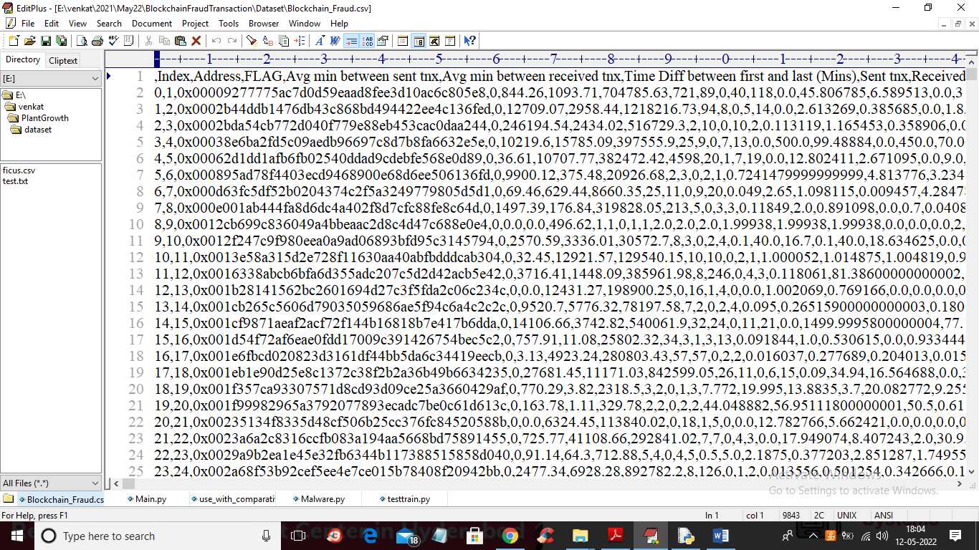
In above screen first row contains dataset column names and remaining rows contains dataset values and in dataset we have column called FLAG which contains values as 0 and 1 where 0 means Normal transaction and 1 means fraud transaction
SCREEN SHOTS
To run project double click on ‘run.bat’ file to get below screen
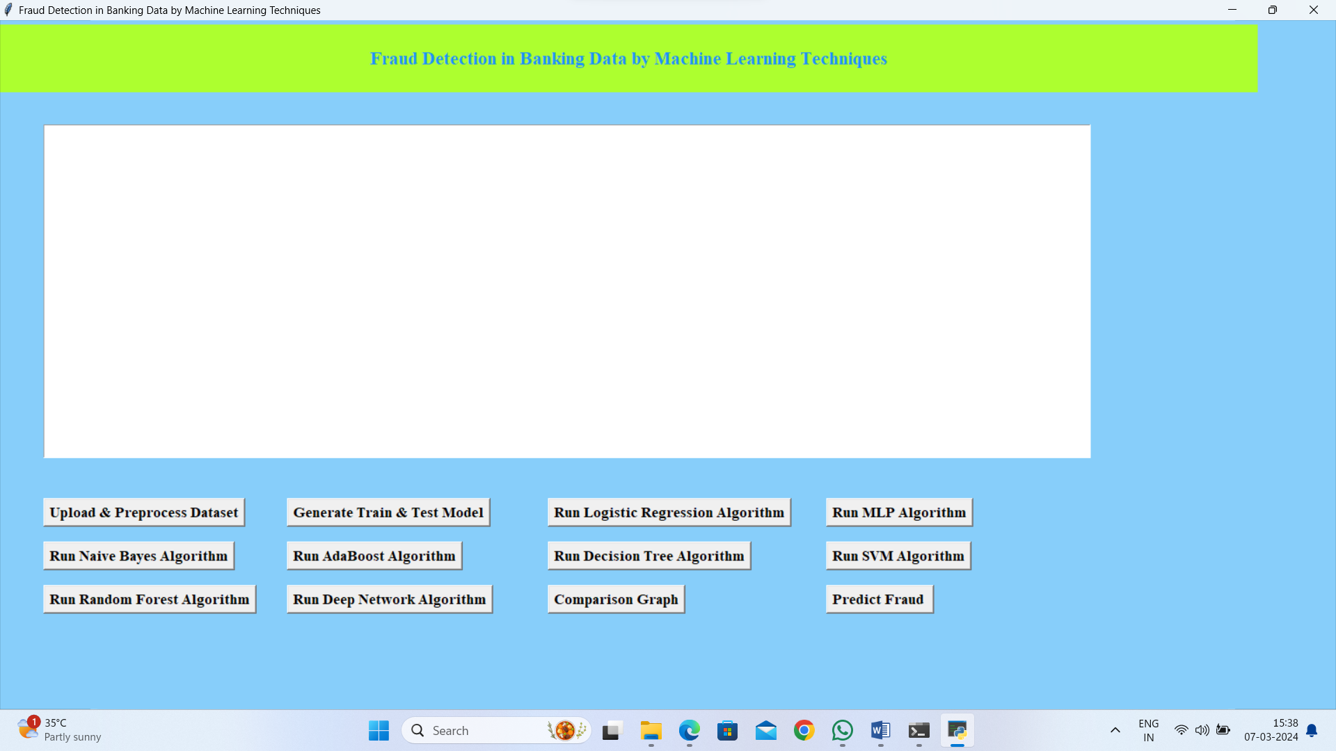
In above screen click on ‘Upload & Preprocess Dataset’ button to upload and read dataset and then remove missing values
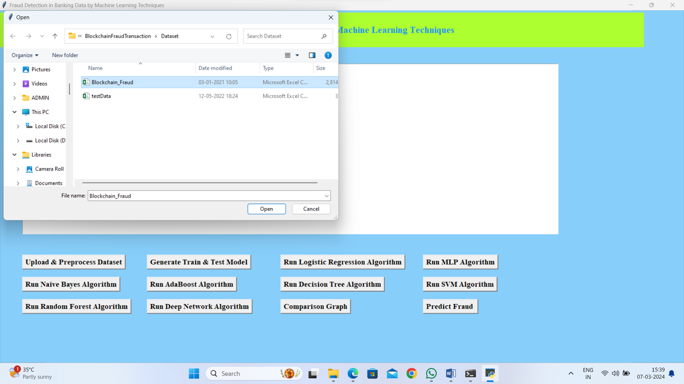
In above screen selecting and uploading dataset and then click on ‘Open’ button to load dataset and get below output
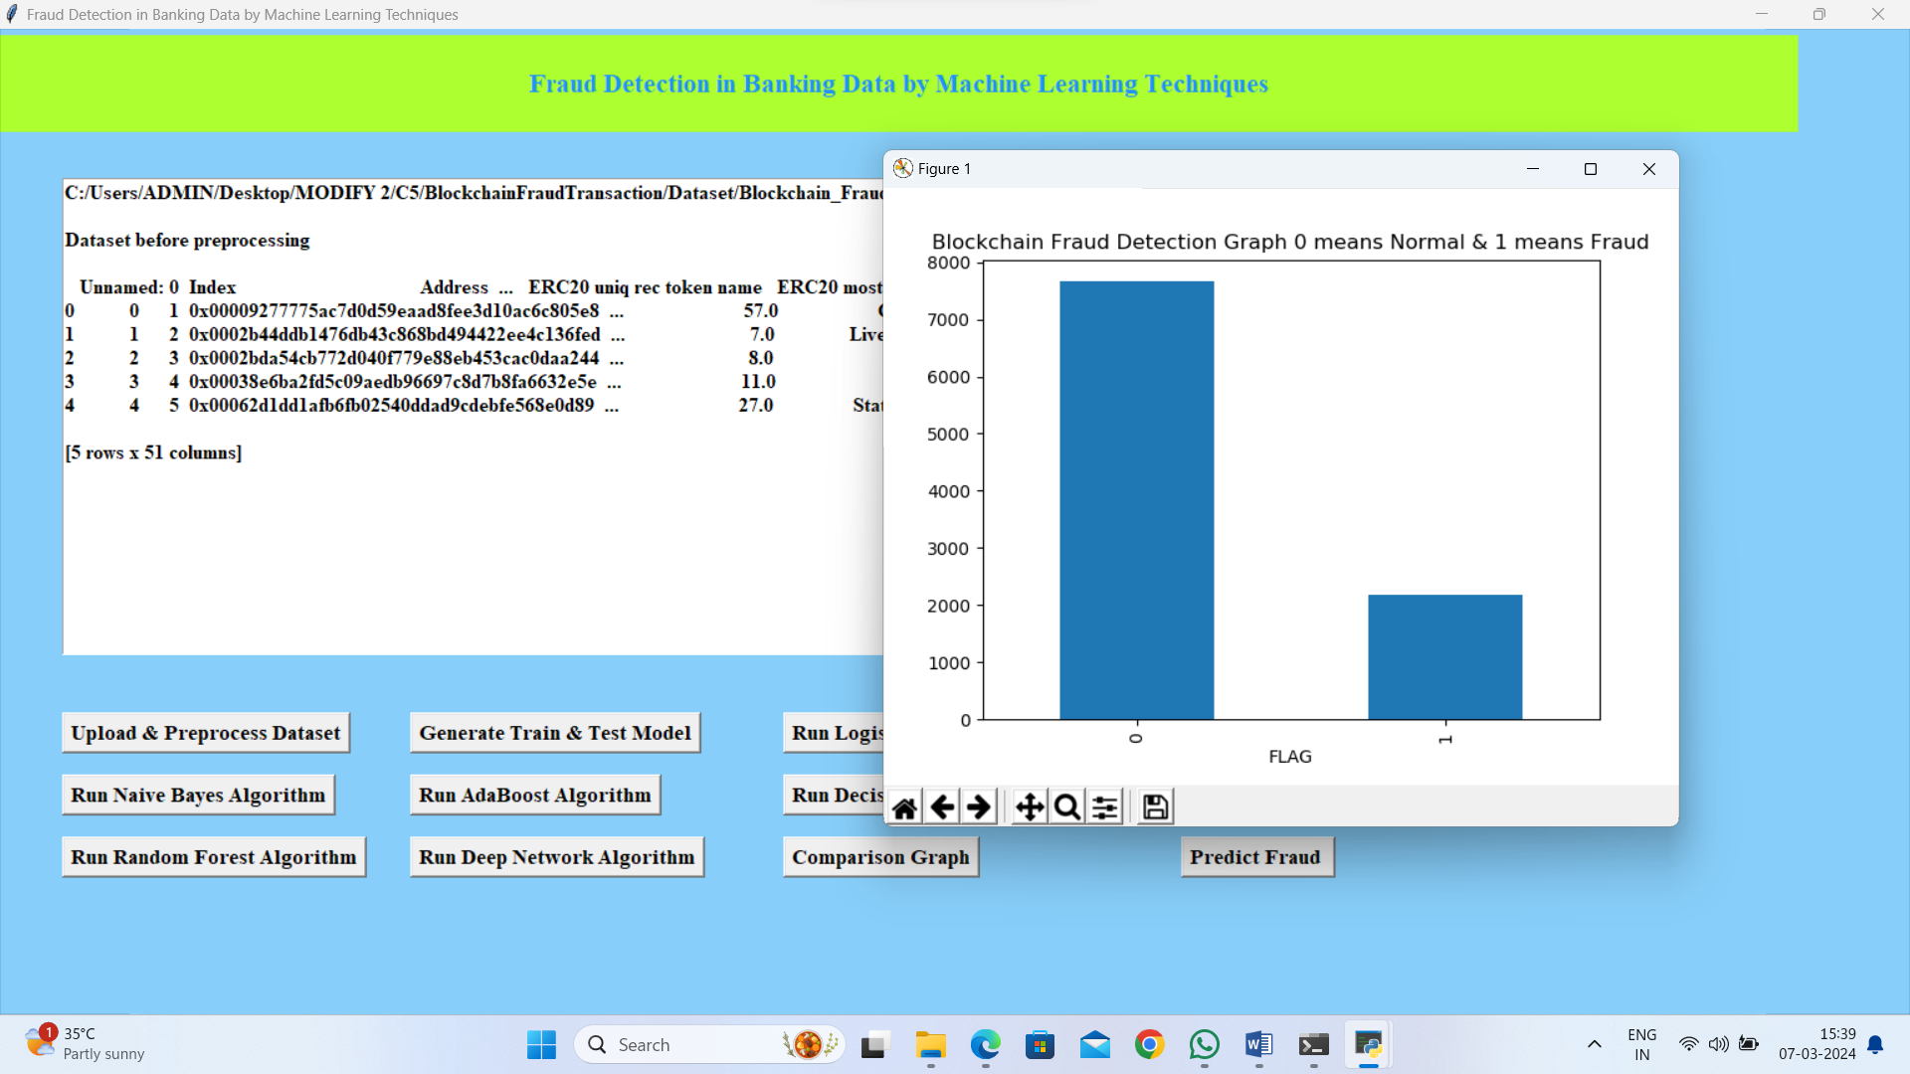
In above screen dataset loaded and dataset contains some non-numeric data and ML algorithms will not take such data so we need to remove and graph x-axis contains type of transaction and y-axis contains number of records and now close above graph and then click on ‘Generate Train & Test Model’ button to get below output
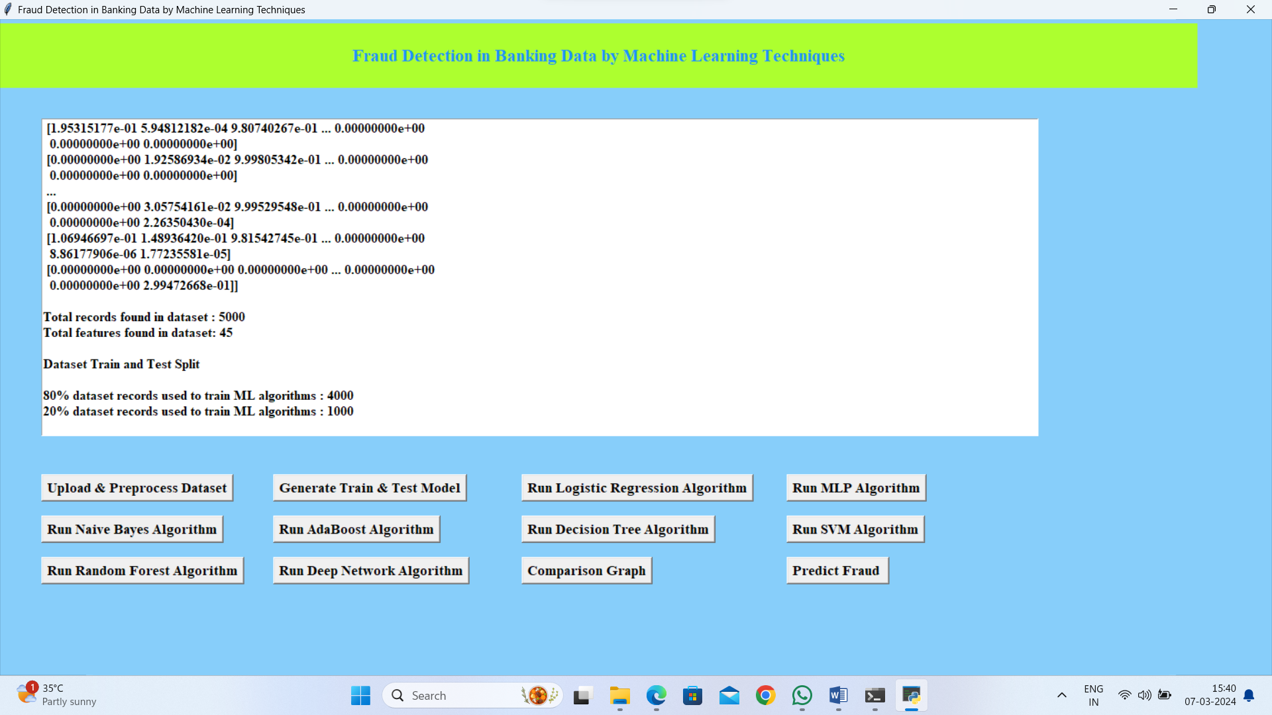
In above screen we can see all data converted to numeric format and we can see total records found in dataset with total columns and then split dataset into train and test and now train and test data is ready and now click on each button to run all algorithms and get below output
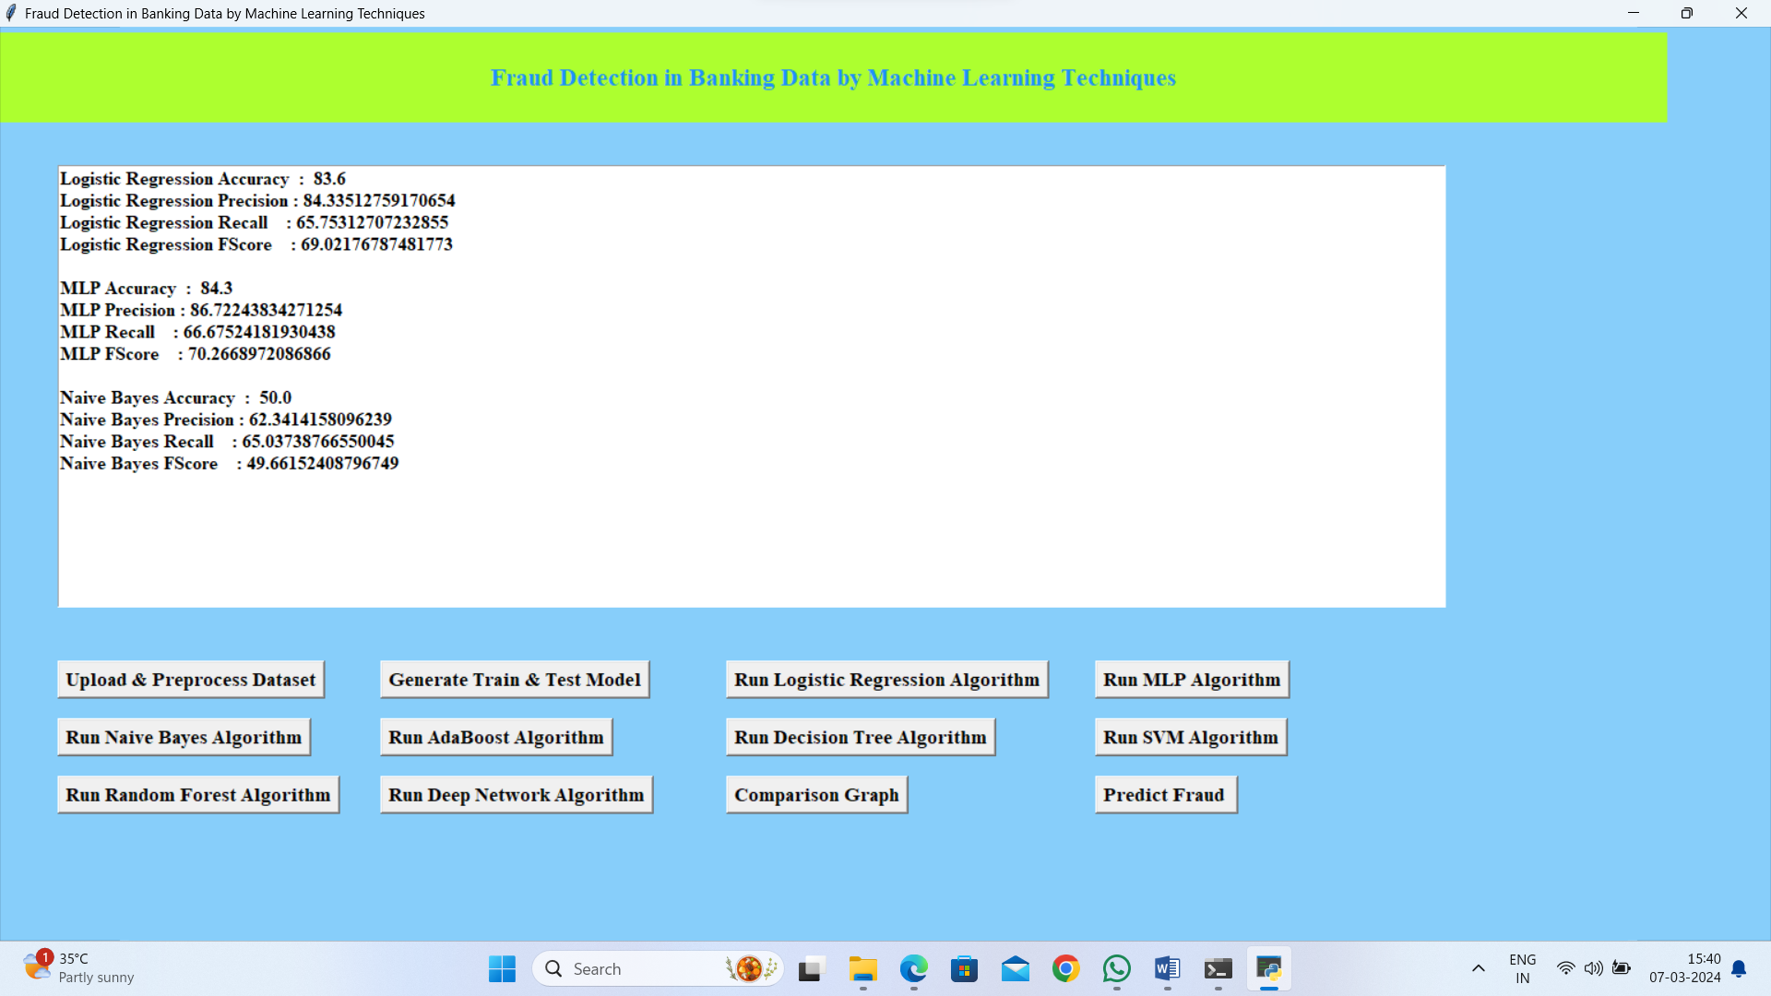
In above screen we can see the performance or accuracy of each algorithm and below is the remaining algorithm accuracy
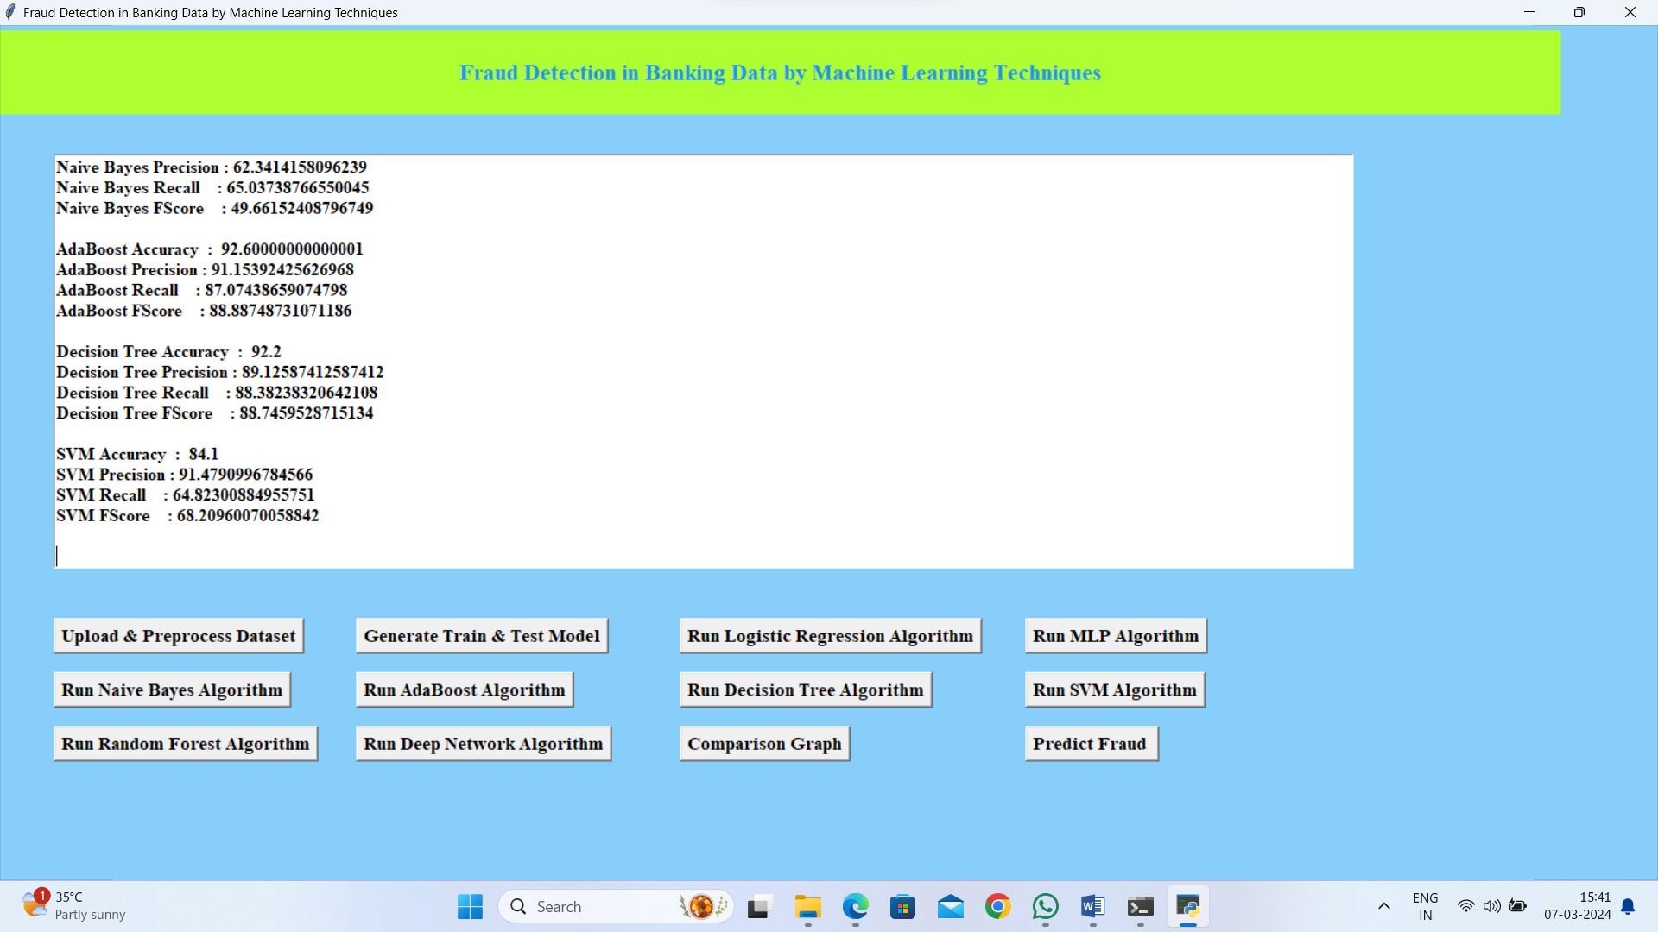
In above screen we can see accuracy of AdaBoost, Decision Tree and SVM and below is the accuracy of remaining algorithms
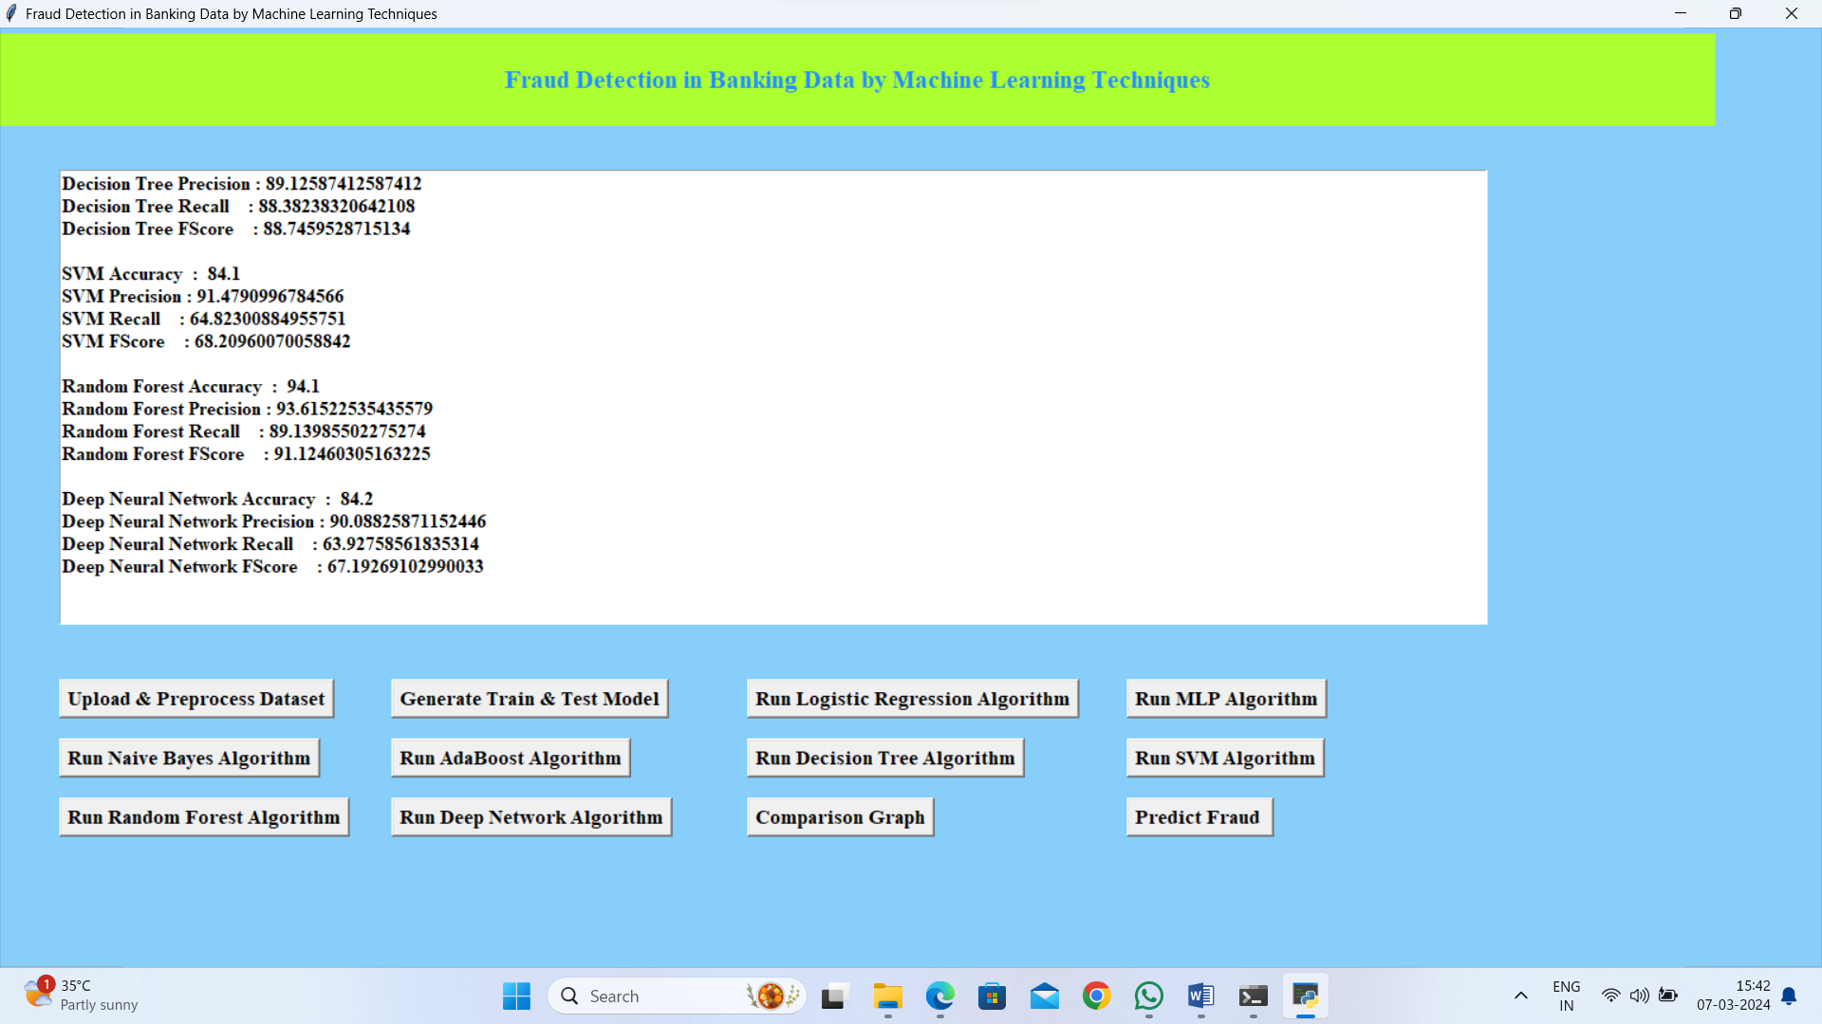
In above screen we can see random forest and Deep neural accuracy and in all algorithms Random Forest is giving better accuracy. Now click on ‘Comparison Graph’ button to get below output
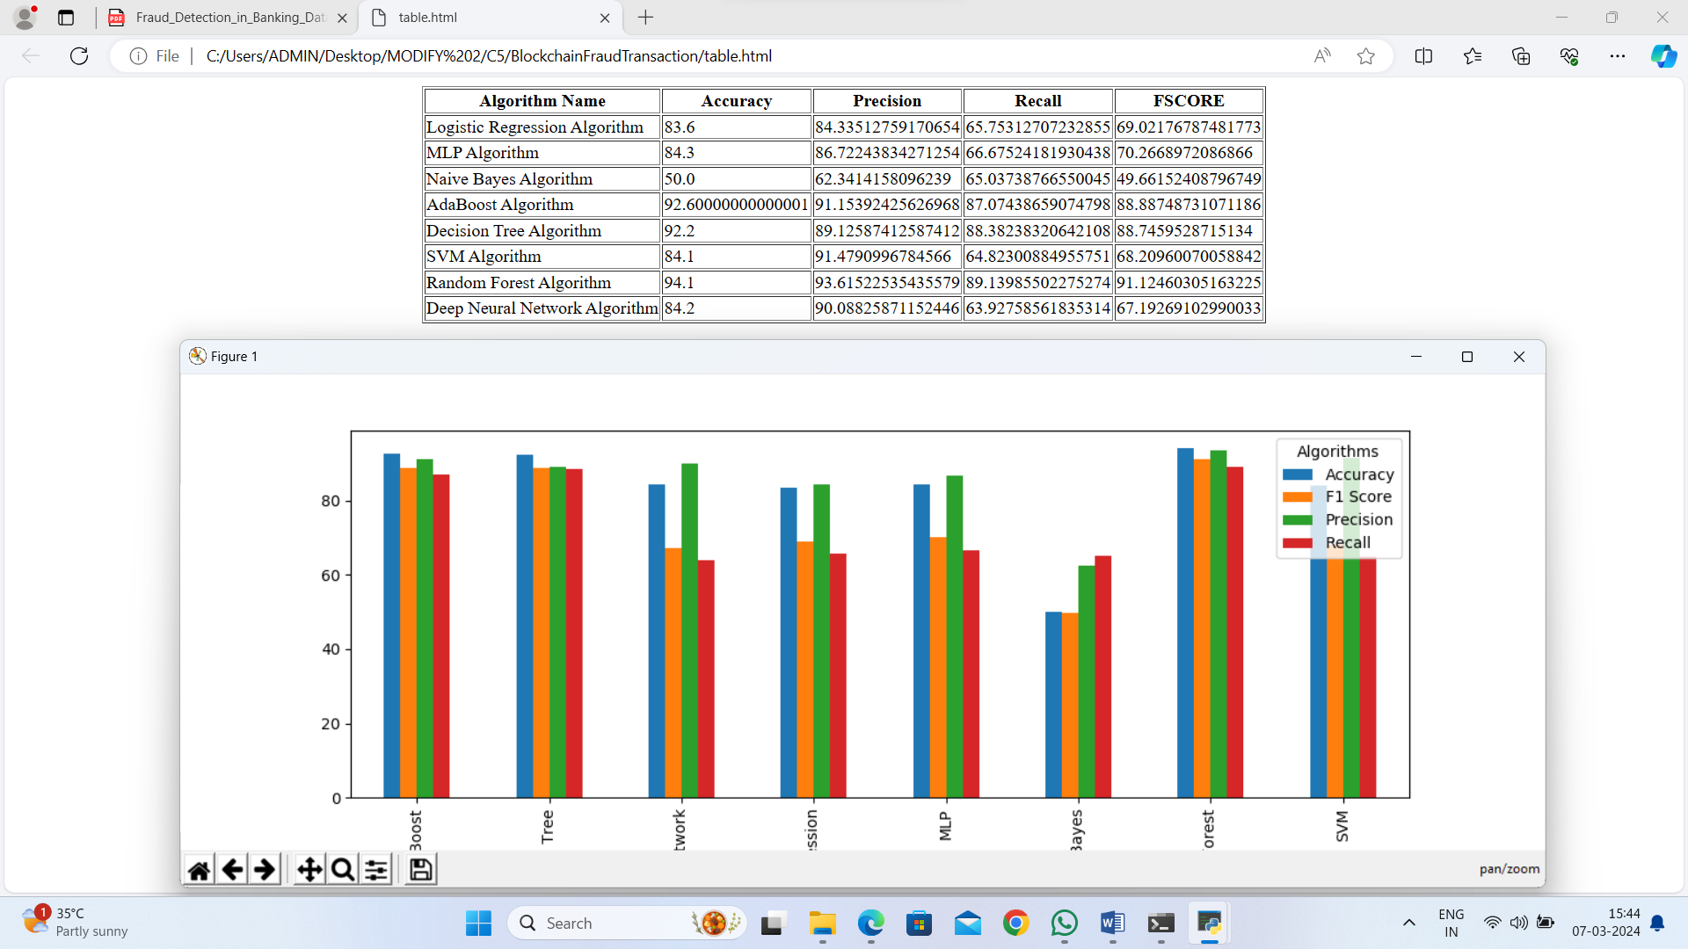
In above screen we can see the accuracy, precision, recall and FSCORE of each algorithm in graph and tabular format and in all algorithms Random Forest giving better result

8. CONCLUSION:
All of the papers mentioned above have introduced blockchain technology and its defining characteristics. They also review state-of-the-art technologies for detecting online fraud and intrusions, identify certain fraud and malicious activities that blockchain technology can effectively prevent, and make recommendations for strategically fighting various attacks to which blockchain technology may be vulnerable. Existing machine learning and data-mining algorithms could find new uses in identifying fraud and intrusions in blockchain-based transactions. Guided machine learning methods like deep-learning neural networks, support vector machines, and Bayesian belief networks may help detect outlier behaviors by profiling, monitoring, and detecting behavioral trends based on people's transaction histories. Despite the advancement in technology, still, the problems regarding Video Fraudulence are faced and there is no concrete solution for this problem. To improve the technology and related anti-attack methods, more research is required.
9. REFERENCES:
[1] Joshi, P., Kumar, S., Kumar, D., & Singh, A. K. (2019, September). A blockchain based framework for fraud detection. In 2019 Conference on Next Generation Computing Applications (NextComp) (pp. 1-5). IEEE.
[2] Cai, Y., & Zhu, D. (2016). Fraud detections for online businesses: a perspective from blockchain technology. Financial Innovation, 2(1), 1-10.
[3] Dhiran, A., Kumar, D., & Arora, A. (2020, July). Video Fraud Detection using Blockchain. In 2020 Second International Conference on Inventive Research in Computing Applications (ICIRCA) (pp. 102-107). IEEE.
[4] Nerurkar P, Bhirud S, Patel D, Ludinard R, Busnel Y, Kumari S. Supervised learning model for identifying illegal activities in Bitcoin. Appl Intell. 2020;209(1):1- 20.
[5] Ostapowicz, M., & Żbikowski, K. (2020, January). Detecting fraudulent accounts on blockchain: a supervised approach. In International Conference on Web Information Systems Engineering (pp. 18-31). Springer, Cham.
[6] Raikwar, M., Mazumdar, S., Ruj, S., Gupta, S. S., Chattopadhyay, A., & Lam, K. Y. (2018, February). A blockchain framework for insurance processes. In 2018 9th IFIP International Conference on New Technologies, Mobility and Security (NTMS) (pp. 1-4). IEEE.
[7] Dhieb, N., Ghazzai, H., Besbes, H., & Massoud, Y. (2020). A secure ai-driven architecture for automated insurance systems: Fraud detection and risk measurement. IEEE Access, 8, 58546-58558.
[8] Shanmuga Priya P and Swetha N, “Online Certificate Validation using Blockchain”, Special Issue Published in Int. Jnl. Of Advanced Networking and Applications (IJANA).
[9] Monamo, P. M., Marivate, V., & Twala, B. (2016, December). A multifaceted approach to bitcoin fraud detection: Global and local outliers. In 2016 15th IEEE International Conference on Machine Learning and Applications (ICMLA) (pp. 188-194). IEEE.
[10] Xu, J. J. (2016). Are blockchains immune to all malicious attacks? Financial Innovation, 2(1), 1-9. [11] M. Young, The Technical Writer’s Handbook. Mill Valley, CA: University Science, 1989.
[12] R. Nicole, “Title of paper with only first word capitalized,” J. Name Stand. Abbrev., in press.
[13] K. Elissa, “Title of paper if known,” unpublished.

